Thinking differently creates space
The ultra-slim Free Slim flap fitting from Häfele
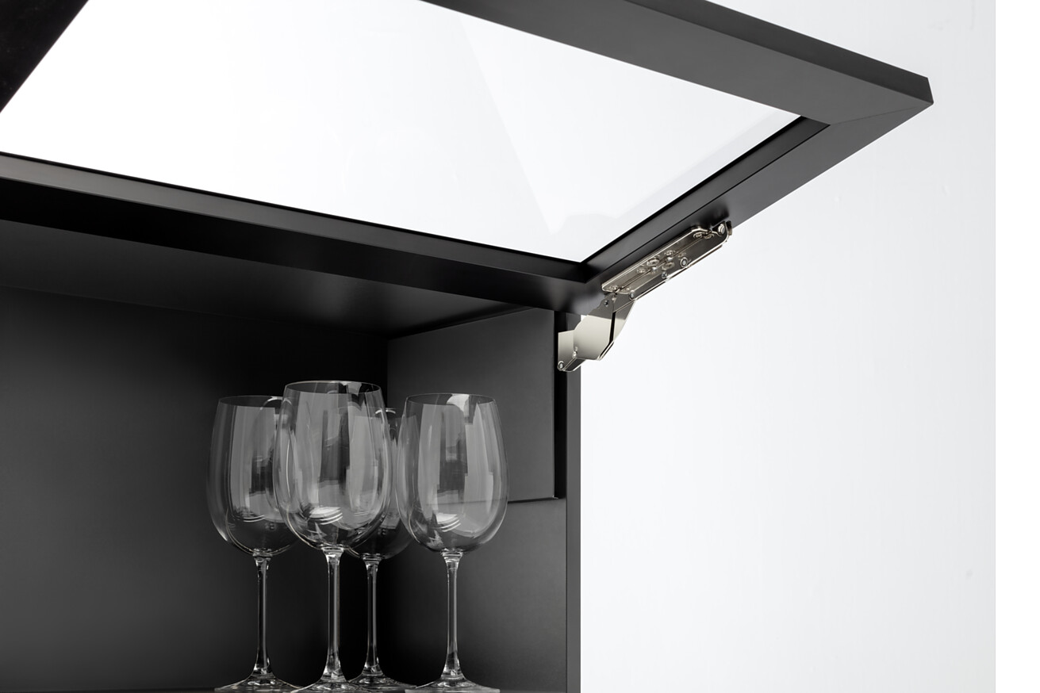

The team at the Flap Competence Center in Budapest has completely redeveloped the revolutionary Free Slim flap fitting. With its innovative technology, it takes flap fittings to a new level in terms of slimness and efficiency. Since it was first unveiled as a study in 2019, it has passed all the necessary tests. The Free Slim flap has already demonstrated its worth in practice with selected partners in the European furniture industry. Now it is time for the next chapter in the success story of Free Slim fittings, which will be showcased at Häfele’s stand at interzum 2025.  The ultra-slim Free Slim flap from Häfele makes use of patented U-springs instead of conventional spiral springs. This is beneficial in several ways: On the one hand, the minimalist product design maximises the amount of storage space in the cabinet. If necessary, Free Slim fittings can even be integrated flush into the side panel from the outside. At the same time, the design optimises the flap cabinet planning process. What was previously an elaborate and complex design process is now child's play thanks to the reduced number of variants for all types of application.  Slim fitting = minimal effort  For industrial furniture production, this results in considerable efficiency gains along the entire production chain: selection, allocation and control processes for different models are significantly reduced or completely eliminated. Inventory management and logistical processes are significantly improved by the flatness of the lift mechanisms.  Pleasant user experience and assured quality  The user experience is by no means neglected: The Free Slim flap has an integrated opening angle adjustment mechanism with continuously adjustable multi-position stop and excellent running properties. Together with selected partners from the European furniture industry, Häfele has been able to fine-tune the product for series production. The outstanding development expertise is reflected in the high product quality: the Free Slim flap is LGA-tested and certified. Flap opening cycle tests yielded results well above the standard expected without any reduction in quality.  One product design for all types of opening  Thanks to the flat but powerful U-spring, the slimline design can also be used for other types of flap opening. Häfele is currently working on developing Free Slim for all other common opening types. With the highest quality standards and the aim of making the planning process as simple as possible for customers in the future, the company is pooling its know-how from different spheres of experience.  Nagold, April 2025  Reprint free of charge / Please send us a copy |  | Company contact person:  Sarah Grünler  Senior Corporate Communications Manager  Häfele SE & Co KG  Tel.: +49 (0)7452 95-510  sarah.gruenler@haefele.de

1 In a completely re-thought approach to technology, Häfele has developed an ultra-slim flap fitting system that is unique in terms of both design and functionality. Photo: Häfele
2 Häfele has collaborated with its partners to add the finishing touches to the Free Slim flap. It meets the required DIN standard and, in the application test, proved to be not only user-friendly but also extremely robust. It is suitable for furniture of all quality levels. Photo: Häfele
3 Häfele draws on its development expertise to set new standards for flap fittings. The ultra-slim Free Slim flap fitting works with patented U-springs. On the one hand, the minimalist design maximises the amount of storage space in the cabinet. On the other hand, the design results in a drastically reduced number of variants for different applications. Photo: Häfele
4 The fitting, which has a slim housing that is just eight millimetres in size, can be used on the right or the left. It thus ensures considerable efficiency gains along the entire production chain in the industrial manufacture of tall cabinets: selection, allocation and control processes for different models are significantly reduced or eliminated altogether. Photo: Häfele
1. |  | 2.
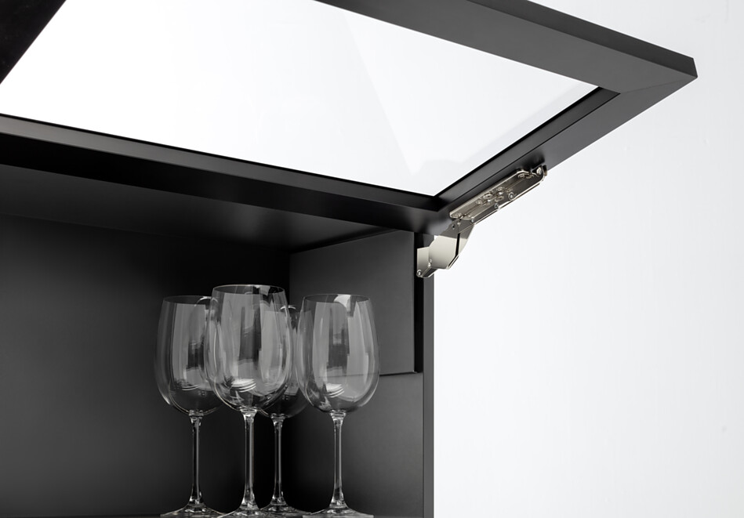 |  | 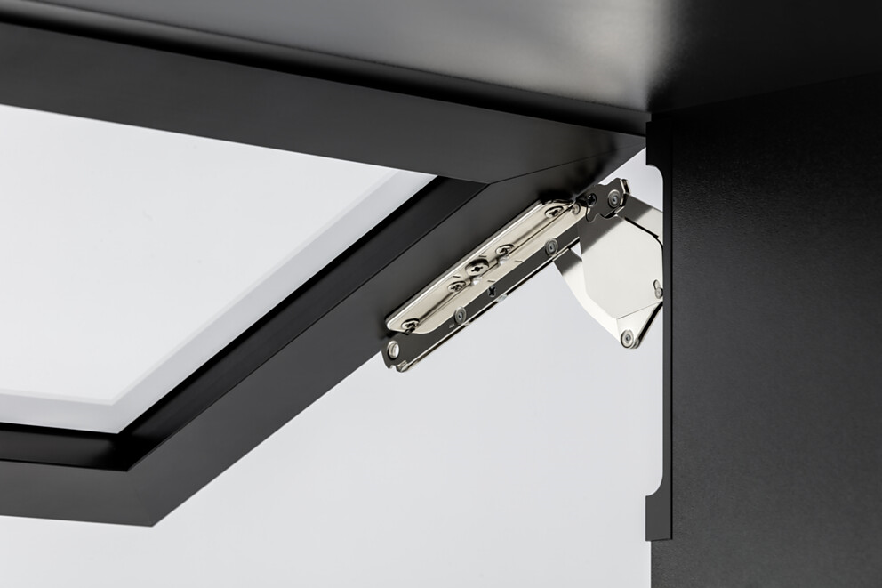
3. |  | 4.
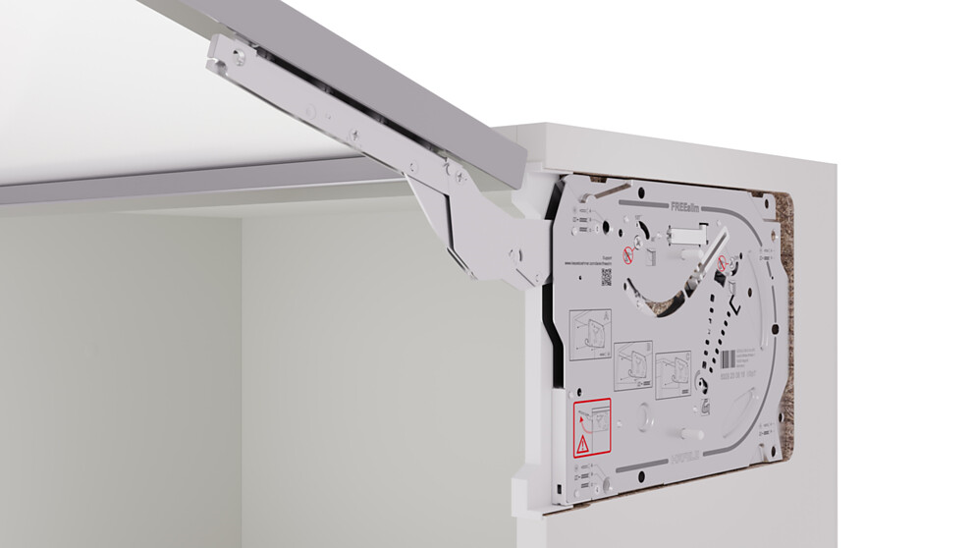 |  | 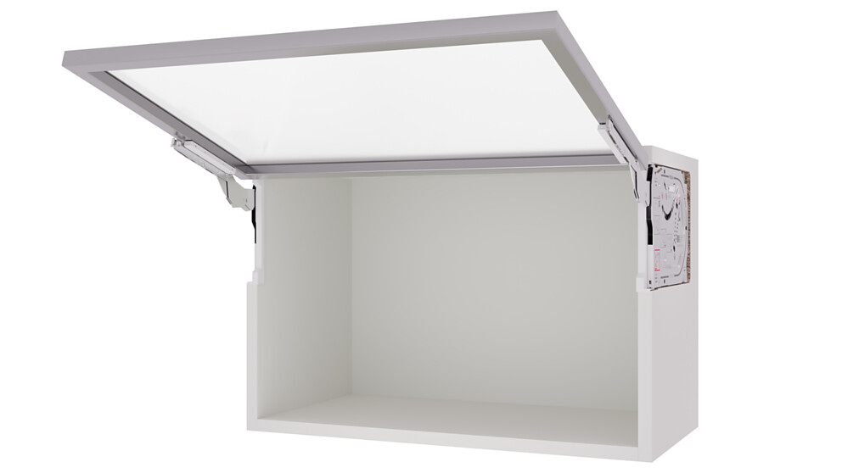

About Häfele
Maximising the value of space. Together.
Häfele is committed to developing liveable, sustainable room concepts for the living and working environments of tomorrow. Together with its partners, Häfele creates resource-saving, multifunctional solutions with maximum comfort.
Founded in 1923, the globally active specialist for intelligent hardware technology, electronic locking systems, lighting and networking offers its customers from over 150 countries unique 360° expertise. With a comprehensive product range, numerous services and a great deal of innovative spirit, the family-owned company is a reliable partner to its partners in the trade, furniture industry, retail and architecture - from brainstorming and planning to the implementation of their projects.
Over 8,000 employees, 38 subsidiaries and numerous other agencies around the world make up the team of the global player headquartered in Nagold in the Black Forest. The Group has been managed by Gregor Riekena since January 2023. Sibylle Thierer represents the interests of the shareholder families as Chairwoman of the Board of Directors. In the 2023 financial year, the Häfele Group achieved a turnover of 1.71 billion euros with an export share of 82%.
Further information can be found at www.haefele.de

QR-Code der Medieninformation


