Häfele Lighting – The ideal symbiosis.
A unique approach to design and planning with furniture and room lighting
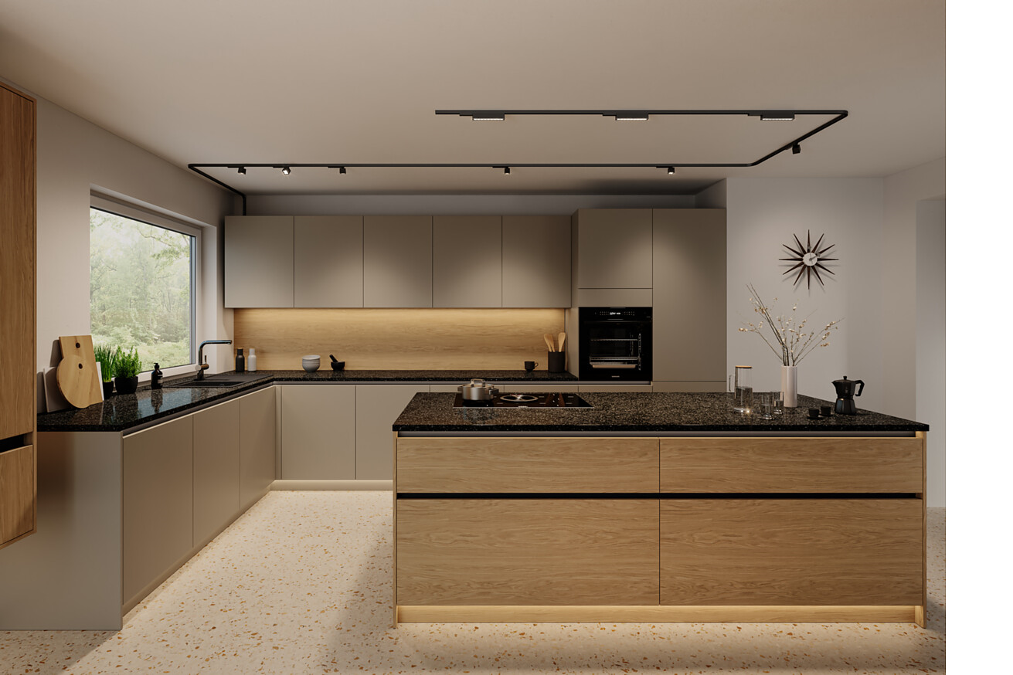

Häfele offers its partners a unique approach to design and planning with furniture and room lighting. After all, Häfele Lighting is the first and to date only brand to combine the application areas of “lighting in furniture” and “lighting in rooms” into an integrated and networked holistic experience. Häfele Lighting solutions are already in use in numerous projects around the world – from healthcare and hotel projects to store fitting, office spaces and residential settings. Häfele will be demonstrating the impressive effect of perfectly harmonised lighting concepts and lighting solutions at the leading international trade fair, interzum 2025, in Cologne.  Furniture lighting creates an atmosphere. Integrated lighting enhances the overall ambience of a room. Room lighting has an impact on the mood and our sense of well-being. It determines how we perceive the environment and what emotions it evokes within us. Targeted lighting design allows the mood to be customised to different requirements. With intelligent control functions, it is possible to blend functionality and atmosphere into perfectly harmonised lighting solutions that increase the comfort and thus the value of the room. Häfele Lighting offers comprehensive solutions for all these scenarios.  Light wherever it is needed  Häfele will present its new 24V lighting system, OneCable, a versatile, straightforward solution for room lighting, at the interzum trade fair. This allows lighting solutions to be seamlessly extended from the furniture into the room. For furniture manufacturers, this increases the scope for design: in addition to light that radiates within the furniture and light that radiates from the furniture into the room, OneCable can also be used to direct light specifically to where it is needed – for example on kitchen islands, dining tables or furniture fronts. As such, it can prove to be an impressive addition to the standard range for kitchen studios or for contract furnishers from other sectors. The really impressive thing about OneCable is that it adapts flexibly to changing room situations – making it ideal as a solution for new builds, but also for renovations or remodelling rooms.  OneCable achieves individuality and creates a special atmosphere through skilful, additive lighting – with minimal installation effort. The system consists of a single profile with corner connectors into which a flat ribbon cable is inserted. It is connected via a conventional 230V socket. Lighting effects can then be added at any point in the system. Various, easily adaptable luminaire types enable both diffuse and focussed lighting. These can be combined at will. Smart control via Häfele Connect Mesh enables customised lighting scenarios to be configured for OneCable.  Linear, versatile and powerful  Be it in kitchens, shops, healthcare, offices or hotels – well-directed, linear light gives rooms a special ambience. The innovative core range of 24V LED strip lights from Häfele Lighting, intended for the design of linear furniture or room lighting, combines all the technical and aesthetic lighting benefits in a clearly structured, high-performance selection.  The Häfele Lighting 24V High Efficiency LED strip lights with 160 lm/W are brand new to the range. They enable the same technology to be used for room and furniture lighting. They are significantly more efficient than conventional standard LED strip lights. This offers several advantages: In addition to their high light output and more homogeneous light pattern, they reduce the overall installation costs, as fewer power supply units or distributors are required. They also have a life time of at least 80,000 hours. On balance, this translates into significantly lower maintenance effort and costs.  The entire Häfele Lighting LED light strip range comprises numerous variants for the design of functional or ambient lighting: It includes colour temperatures from 2700 K to 5000 K as well as standard, RGB, Tunable White, silicone and COB LED strips lights. The section length is 50 millimetres for standard variants and a minimum of 16 millimetres for COB strips. The installation process is also extremely straightforward – all LED strip lights are compatible with Häfele’s range of accessories.  Lighting scenarios that appear as if by magic  The interplay between the lighting elements is decisive for the spatial effect. To network the Bluetooth® Mesh-compatible Häfele Lighting components with each other, Häfele offers the Connect Mesh app, a mobile application that can be used to set up and control Häfele Lighting luminaires.  Users can enjoy the benefits of a completely intuitive operating mode. It is also possible to customise or automatically switch between dark and light modes. The dashboard gives users quick access to frequently used functions: certain features can be prioritised in the app by simply marking them. What's more, automated time control makes things even more convenient. Smart home devices can be operated by voice command and seamlessly integrated using Häfele Connect Gateway and Alexa.  An entirely new feature in the current version 2.2 is that established networks can be synchronised on multiple devices via a cloud. Mesh boxes and assigned lights are now also linked visually on the screen display. This makes it easier to identify the nodes, as the relevant mesh box flashes when tapped in the app. The app also recognises components that have already been integrated into the network. This means it can quickly restore associated functions if required.  Häfele Services – Reliable partners throughout the entire process  Customers who want to design and implement lighting solutions can utilise Häfele’s extensive Plus services if they wish. The programme offers expert support throughout the entire work process.  From knowledge acquisition (Häfele Academy) to consulting support (Häfele Lighting Manual), planning aids (e.g. lighting proposals) and production facilitation (e.g. pre-assembled LED linear lights) to installation and maintenance (Technical Lighting Support).  The broad spectrum covered by Häfele Service+ thus creates real added value for industrial and artisanal furniture production and interior design with lighting solutions from Häfele Lighting.  Discover the full range of services at The Plus Services | HÄFELE.  Nagold, April 2025  Reprint free of charge / Please send us a copy |  | Company contact person:  Sarah Grünler  Senior Corporate Communications Manager  Häfele SE & Co KG  Tel.: +49 (0)7452 95-510  sarah.gruenler@haefele.de

1 The OneCable lighting system from Häfele Lighting creates a unique atmosphere thanks to skilful, additive light control – with very little effort. The power supply is routed flexibly along the ceilings and walls in the room. As such, it can prove to be an impressive addition to the standard range for kitchen studios or for bathroom fitting companies. Photo: Häfele
2 Various light sources for the OneCable lighting system — from the rotatable and swivelling Spot 4 TT light to the linear, fixed Spot 9 light and the 8 mm Loox LED strip light that can be individually cut to length, various light types can be used to provide diffuse or focussed light and can also be combined with each other. They can be easily inserted into the profile and repositioned at will – thanks to the reverse polarity protection, there is no risk of incorrect installation. Photo: Häfele
3 Linear lighting lends rooms that certain something. The innovative 24V LED strip light range from Häfele Lighting, intended for the design of indirect furniture or room lighting, combines all the technical and aesthetic lighting benefits in a clearly structured, high-performance selection. The installation process is extremely straightforward, since all the LED strip lights are compatible with Häfele’s range of accessories. Photo: Häfele
4 The Häfele Lighting 24V High Efficiency LED strip lights with 160 lm/W are brand new to the range and can be used to create impressive linear lighting. In addition to their high light output, they reduce the overall installation costs because less powerful power supply units or distributors are required. They also have a very long life time, which translates into significantly lower maintenance requirements and costs. Photo: Häfele
1. |  | 2.
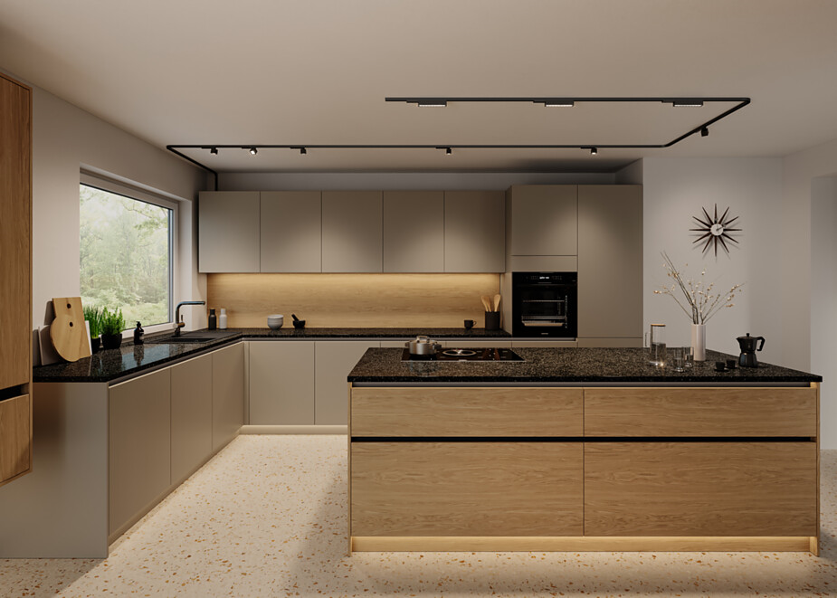 |  | 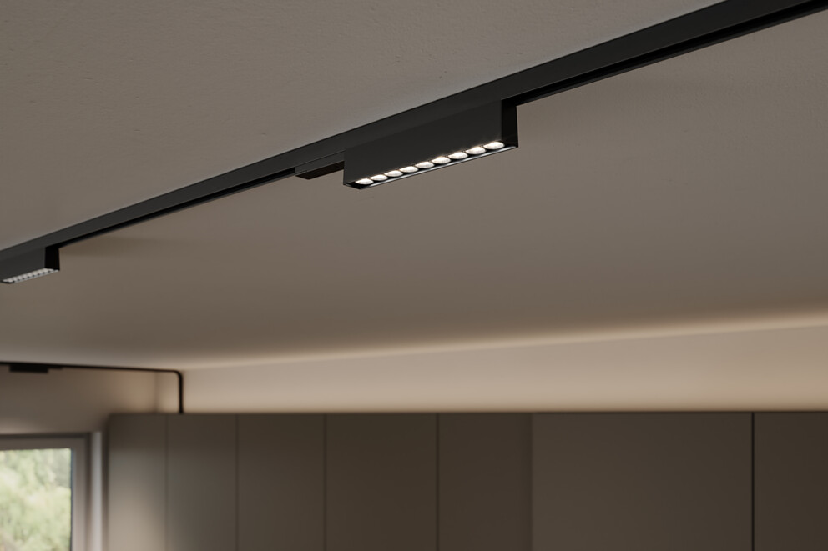
3. |  | 4.
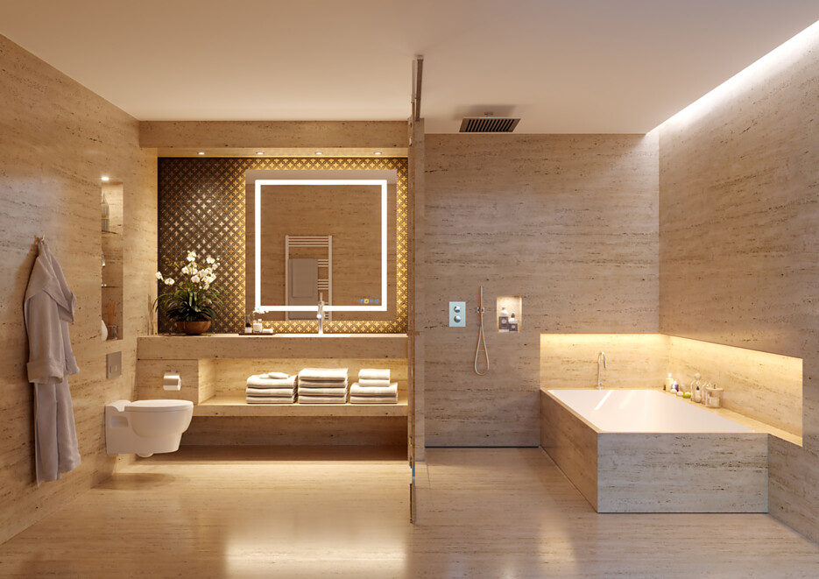 |  | 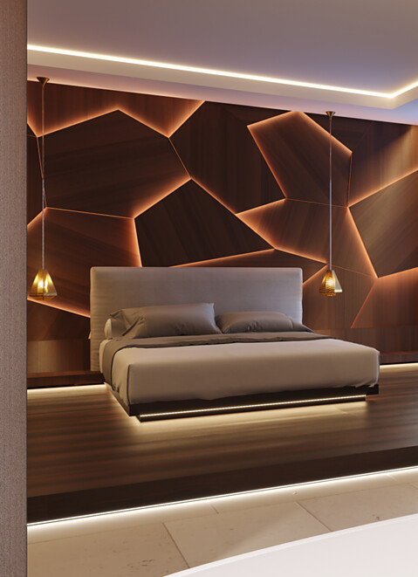

5 To network the Bluetooth® Mesh-compatible Häfele Lighting components with each other and control them, Häfele offers the Connect Mesh App 2.2, a mobile application that can be used to set up and control Häfele Lighting luminaires. This makes it simple and convenient to programme different lighting scenarios. For example, functional lighting can be selected in the kitchen and dining room for cooking and dining. Photo: Häfele
6 Atmospheric lighting is preferable for the evening hours or for celebrations. The interplay between the lighting elements is decisive for the spatial effect. Photo: Häfele
7 The new dashboard of the Häfele Connect Mesh App 2.2 provides quick access to frequently used functions. They can be prioritised by simply marking them and, if required, an integrated time control system can automatically apply the various scenarios. Photo: Häfele
5. |  | 6.
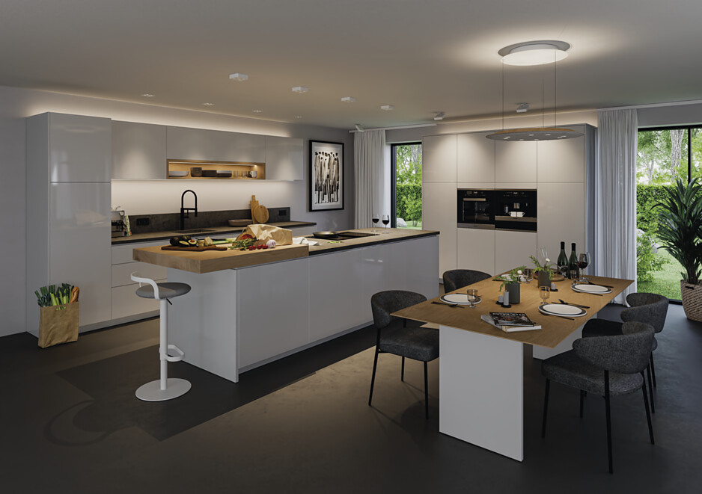 |  | 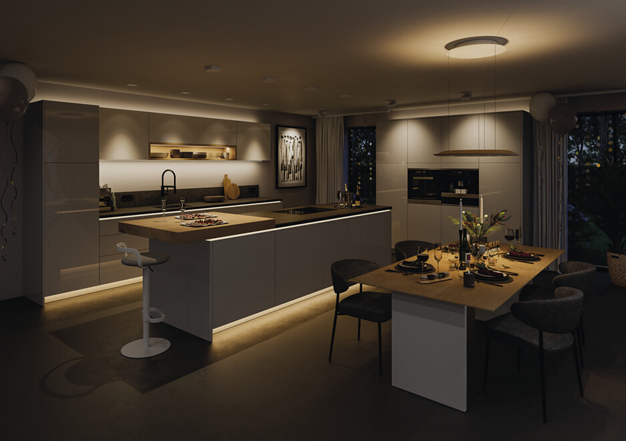
7.
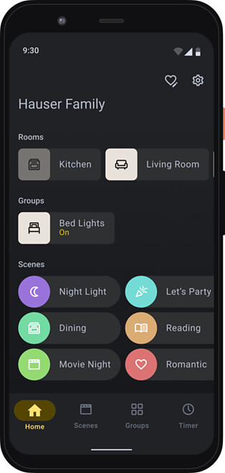

About Häfele
Maximising the value of space. Together.
Häfele is committed to developing liveable, sustainable room concepts for the living and working environments of tomorrow. Together with its partners, Häfele creates resource-saving, multifunctional solutions with maximum comfort.
Founded in 1923, the globally active specialist for intelligent hardware technology, electronic locking systems, lighting and networking offers its customers from over 150 countries unique 360° expertise. With a comprehensive product range, numerous services and a great deal of innovative spirit, the family-owned company is a reliable partner to its partners in the trade, furniture industry, retail and architecture - from brainstorming and planning to the implementation of their projects.
Over 8,000 employees, 38 subsidiaries and numerous other agencies around the world make up the team of the global player headquartered in Nagold in the Black Forest. The Group has been managed by Gregor Riekena since January 2023. Sibylle Thierer represents the interests of the shareholder families as Chairwoman of the Board of Directors. In the 2023 financial year, the Häfele Group achieved a turnover of 1.71 billion euros with an export share of 82%.
Further information can be found at www.haefele.de

QR-Code der Medieninformation


