Uniting reliability with ambition
Furniture connectors from Häfele: Developed and produced with foresight
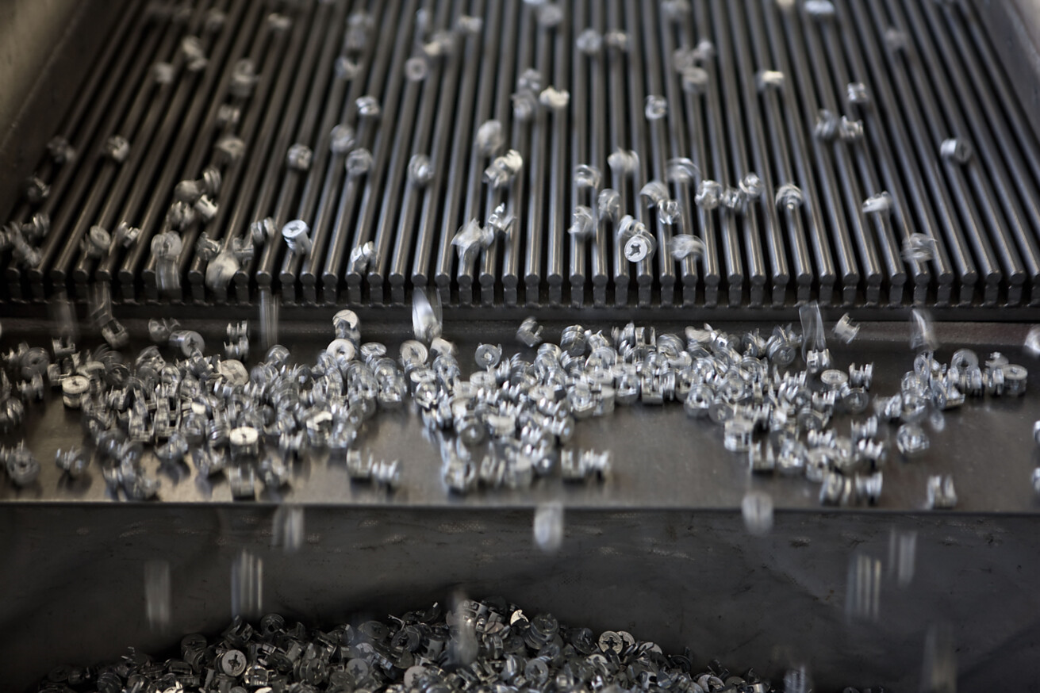

Ingenuity and a forward-looking approach – with its outstanding ideas and solutions for furniture connectors, this is what Häfele has been synonymous with for decades now. One of the most well-known is the Minifix®, the pioneer of modern cabinet connectors, as well as the single-part Ixconnect SC 8/25 and SC 8/60 spreading connectors, which can be installed almost invisibly. To this day, the company is a true driver of innovation in this field. Häfele’s latest furniture connectors, which will be on show at interzum 2025, address key issues of the future. When developing and manufacturing them, Häfele focussed on the careful use of materials, the conservation of scarce resources and the holistic design of rooms.  At the trade fair, Häfele will be demonstrating how it is addressing the trend towards ever slimmer cabinet walls with a piece of furniture made from panel material that is just 12 millimetres thick. The Minifix® 12/15 and the Ixconnect CC 8/5/30 claw connector, among others, offer robust connections for this material thickness. Häfele’s Ixconnect furniture connectors are developed and manufactured at the Häfele factory in Berlin and are certified to German quality standards for high product safety and reliability.  Unmistakable qualities  Whether it’s cabinet connectors, shelf supports or shelf connectors, panel connectors or back panel connectors – as a developer and manufacturer of furniture connectors, Häfele is simply unmistakable. That’s because the company not only has generations of experience under its belt, but also pools all the necessary expertise under one roof. This ranges from highly qualified expertise, modern production facilities and manufacturing processes to innovative material technologies and efficient logistics systems.  For decades now, Häfele has been monitoring the global market intensively and collaborating with its international partners from the furniture industry on future-orientated solutions. The company develops, manufactures and optimises high-performance furniture connectors according to customer requirements – both efficiently and in a customised manner. With its extensive knowledge of materials, production processes and application techniques, Häfele works with its customers to develop solutions that are always tailored to the furniture quality and production method. This actively reduces process and production costs.  One for (almost) everything – the UC 16/64 universal connector  The latest member of the Häfele Ixconnect connector family is the universal connector UC 16/64, which impresses with its sophisticated, resource-saving design. This compact all-rounder brings together a surprising number of furniture connector variants into a single product and can therefore be used flexibly in a wide variety of installation situations. Whether it’s used as a single-piece corner connector, or used for corner applications, for panel mounting or as a traditional connecting bracket: it is multifunctional, as you can create countless stable connections with it, depending on how you combine two or even more of these sophisticated connectors. This also reduces the amount of stock that needs to be held. What’s more, with the UC 16/64 universal connector, assembly teams will be ideally prepared for any situation while saving space and weight in the vehicle.  Connector expertise that ticks all the boxes: customised packaging  As part of its “Service+ Customised” offering, Häfele designs and produces customised bag and cardboard packaging for furniture connectors, but also for complete furniture production units. Häfele is able to package almost any number of pieces, any composition and any format. Be it fittings bags, “bag in bag” packaging, “bag in cardboard” packaging, cardboard packaging or special packaging – Häfele develops customised packaging solutions in close cooperation with its customers, thereby creating real added value for industrial and artisanal furniture production. That’s because components that are delivered ready to use end up simplifying the entire production process.  Discover Häfele’s “Service+ Customised” offer at Packaging Engineering | HÄFELE.  Nagold, April 2025  Reprint free of charge / Please send us a copy | Company contact person:  Sarah Grünler  Senior Corporate Communications Manager  Häfele SE & Co KG  Tel.: +49 (0)7452 95-510  sarah.gruenler@haefele.de
1 The Minifix® from Häfele is the pioneer of modern cabinet connectors and is representative of Häfele’s high standard of manufacturing expertise in the field of furniture connectors. Many furniture connectors from Häfele – including the well-known Ixconnect family, for example – are developed and manufactured at the Häfele plant in Berlin. With their certified German quality standards, they ensure a high level of product safety and reliability. Photo: Häfele
2 In furniture construction, there is a trend towards using slim panels. What solutions does Häfele have in store for this at interzum? For example, the petite Minifix® 12. Photo: Häfele
3 The Minifix® 12 can be coupled to the panel material of the front panel using a connecting bolt, thus ensuring safety and stability even when using slim materials. This connector ensures a positive fit despite its small size and even after repeated slackening and re-tightening. Photo: Häfele
4 The spreading connectors in the Ixconnect family have also been favourites in the Häfele range for a long time now. This is the Ixconnect SC 8/25 for assembling lightweight furniture. It can be fitted almost invisibly and won the “Best of the Best” award at interzum 2017 – and thus the highest honour. Photo: Häfele
1. |  | 2.
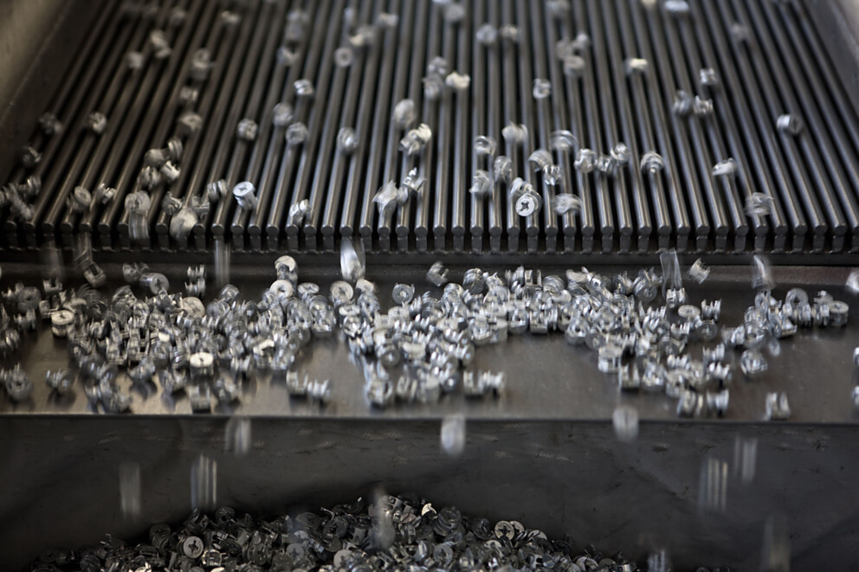 |  | 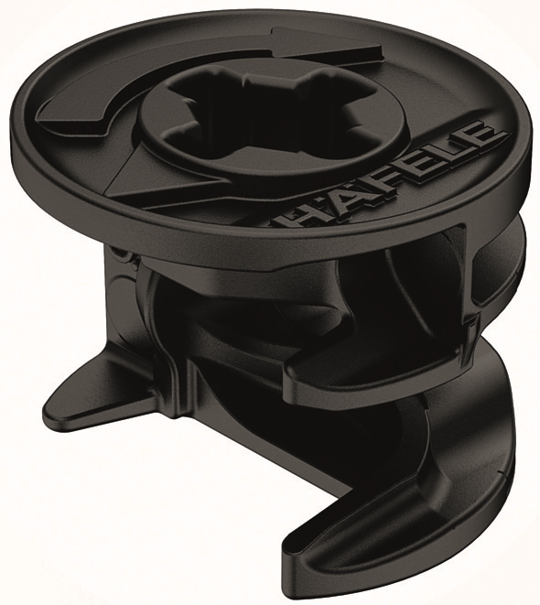
3. |  | 4.
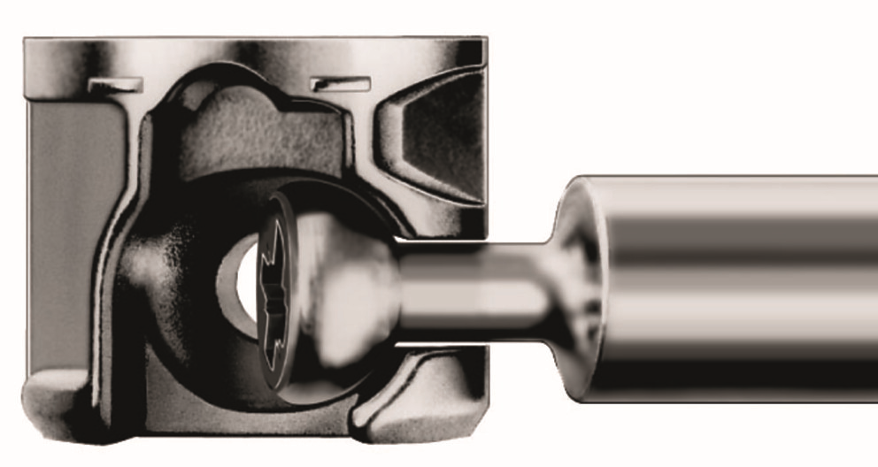 |  | 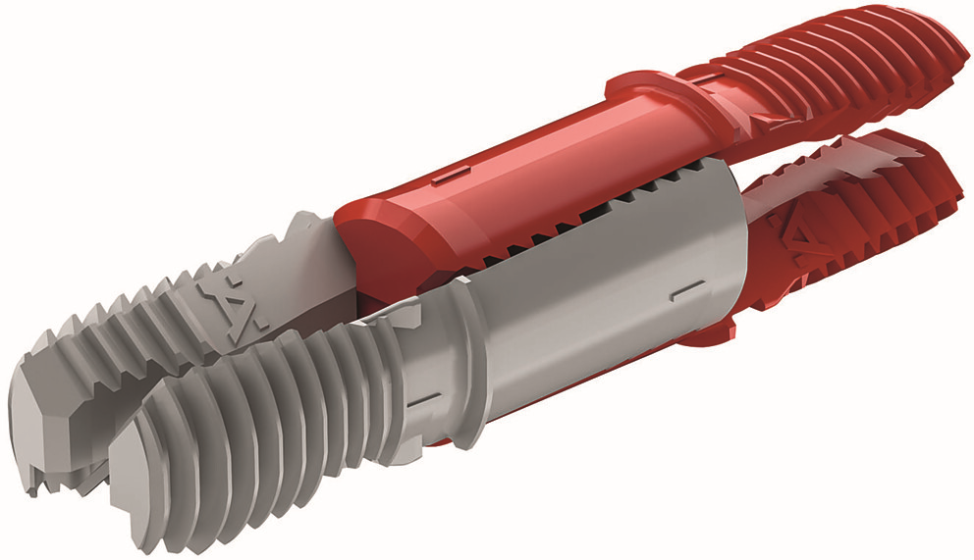

5 A completely new Häfele connector concept: one component for a wealth of possible applications — as can be seen here in the functional diagram of the universal connector Ixconnect UC 16/64, which will be on show at interzum. Photo: Häfele
6 This little all-rounder was created by Häfele: A complex component made up of several identical parts that can be used for almost any type of panel connector. In many respects, this is a resource-saving solution that once again demonstrates Häfele’s development expertise. Photo: Häfele
5. |  | 6.
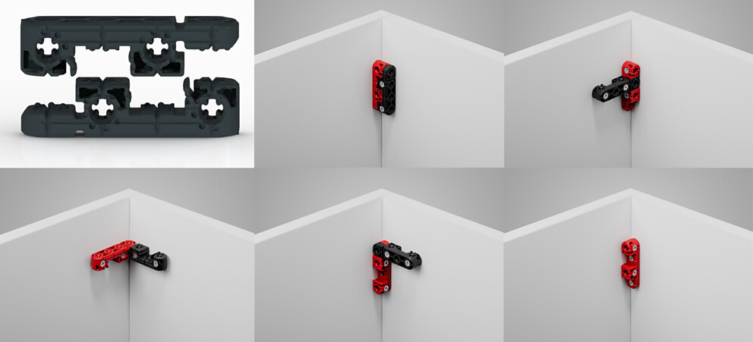 |  | 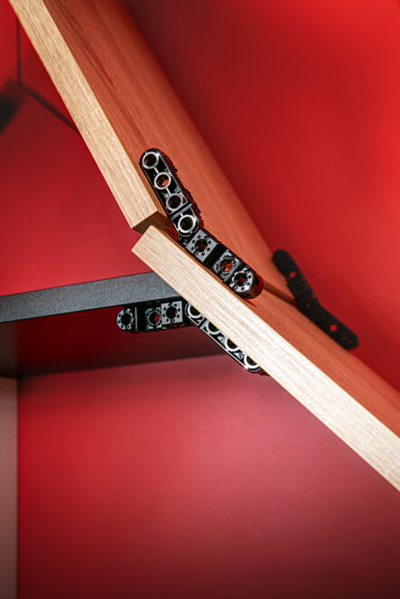

About Häfele
Maximising the value of space. Together.
Häfele is committed to developing liveable, sustainable room concepts for the living and working environments of tomorrow. Together with its partners, Häfele creates resource-saving, multifunctional solutions with maximum comfort.
Founded in 1923, the globally active specialist for intelligent hardware technology, electronic locking systems, lighting and networking offers its customers from over 150 countries unique 360° expertise. With a comprehensive product range, numerous services and a great deal of innovative spirit, the family-owned company is a reliable partner to its partners in the trade, furniture industry, retail and architecture - from brainstorming and planning to the implementation of their projects.
Over 8,000 employees, 38 subsidiaries and numerous other agencies around the world make up the team of the global player headquartered in Nagold in the Black Forest. The Group has been managed by Gregor Riekena since January 2023. Sibylle Thierer represents the interests of the shareholder families as Chairwoman of the Board of Directors. In the 2023 financial year, the Häfele Group achieved a turnover of 1.71 billion euros with an export share of 82%.
Further information can be found at www.haefele.de

QR-Code der Medieninformation


