A simple and beautiful sliding action
Slido F-Flush57 with flush-mounted appearance
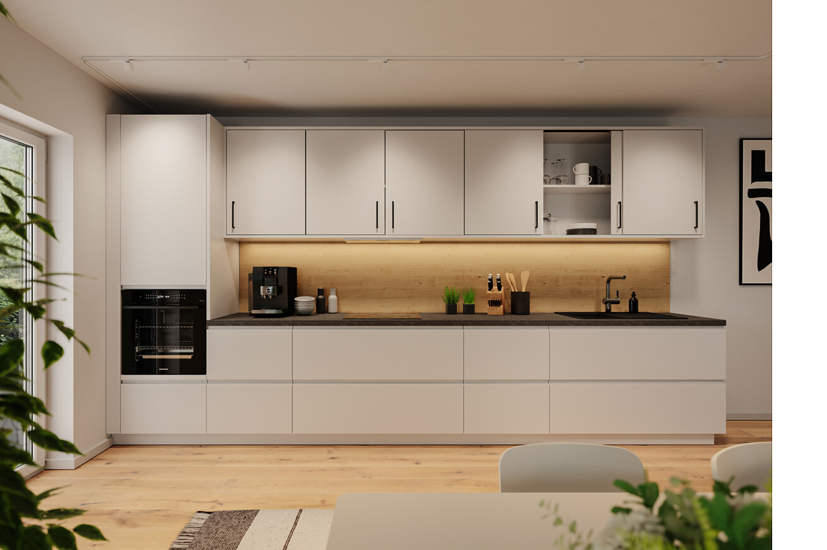

At interzum 2025, Häfele will be presenting an addition to its range of sliding hardware for furniture: the brand new Slido F-Flush57 is the ideal solution for optimising space utilisation in furniture with minimal space requirements. This is because the innovative technology of the sliding furniture door fittings enables a flush design. It therefore offers not only functional, but above all aesthetic benefits for a wide range of applications in kitchens, offices, bathrooms and living rooms. Slido F-Flush57 is available from May 2025 onwards.  Sliding door systems are a clever way of dealing with the increasing lack of space in modern kitchens, living areas and workspaces. Slido F-Flush57 allows for a uniform, smooth furniture surface, ensuring a sleek look without protruding doors. The flush-mounted Infront technology allows the doors to be opened fully, thus maximising access to the storage space.  A wide range of applications  Slido F-Flush57 is a versatile sliding solution for a wide range of living areas and workspaces. In office settings, the fitting is ideal for sideboards, storage space solutions in partition elements or printer cabinets. In bathrooms, it is particularly beneficial for vanity units or mirror cabinets, whereby mirror fronts can also be fitted without any issues. In living areas, the Slido F-Flush57 can be used in a variety of ways in wall units, TV base units, table bases, wardrobes or for storage solutions in sloping ceilings. In kitchens, it facilitates a particularly space-saving design – for wall units, for example.  Straightforward manufacture and installation  One of the major advantages of the Slido F-Flush57 is how easy it is to work with during furniture construction. Assembly can be carried out quickly and efficiently thanks to identical drilling patterns for the doors and a simple groove in the base and top cover. The ability to use extremely thin doors with a material thickness starting at eight millimetres offers additional flexibility when choosing materials.  Cost-efficient and durable  Thanks to its sophisticated design, the Slido F-Flush57 comprises a small number of cost-optimised components. The simple production process makes series production straightforward and allows for cost-effective use even in price-sensitive furniture segments. Compared to competitor products with similar properties, the Slido F-Flush57 offers both a significant price advantage and a high level of quality.  Adaptable to individual needs  The Slido F-Flush57 has been developed for a wide range of door formats and therefore offers a high degree of flexibility in use. Doors can be up to 880 millimetres wide and up to 1,100 millimetres high. The door thickness can vary flexibly between eight and 16 millimetres, and the system is designed for a door weight of up to six kilograms per door. Häfele uses high-quality plastic glides combined with a robust track made of powder-coated aluminium.  Nagold, April 2025  Reprint free of charge / Please send us a copy |  | Company contact person:  Sarah Grünler  Senior Corporate Communications Manager  Häfele SE & Co KG  Tel.: +49 (0)7452 95-510  sarah.gruenler@haefele.de

1 Smooth furniture surfaces and space-saving design: The Slido F-Flush57 gives kitchens a consistent appearance and is easy to integrate thanks to the simple installation process and flexible choice of materials. Photo: Häfele
2 Perfect for offices: The Slido F-Flush57 is an elegant solution for sideboards, partition elements and printer cabinets – with flush-mounted technology for a sleek, modern look and ideal access to storage space. Photo: Häfele
3 Ideal for bathrooms: The Slido F-Flush57 optimises vanity units and mirror cabinets – even if they have mirror fronts. Photo: Häfele
4 Versatile in living areas: The Slido F-Flush57 fits perfectly into wall units, TV base units, table bases and sloping ceilings. Photo: Häfele
1. |  | 2.
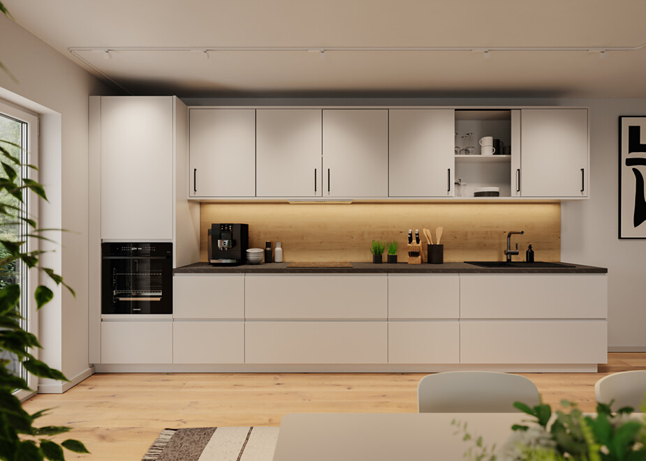 |  | 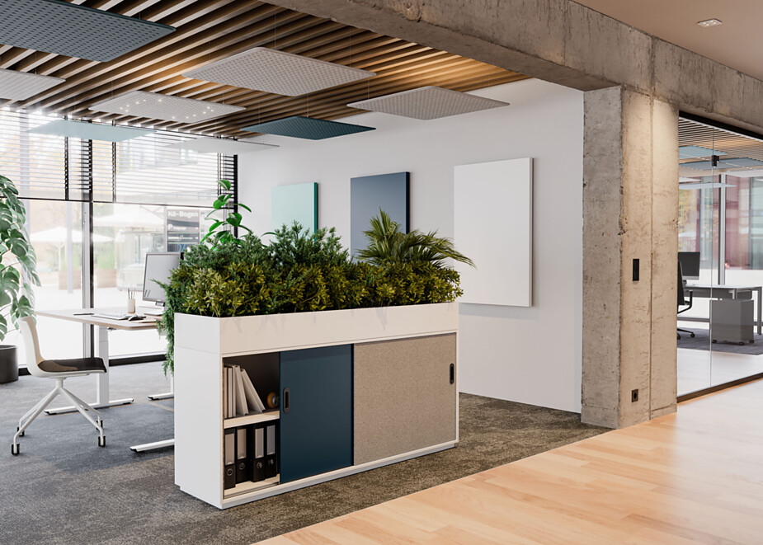
3. |  | 4.
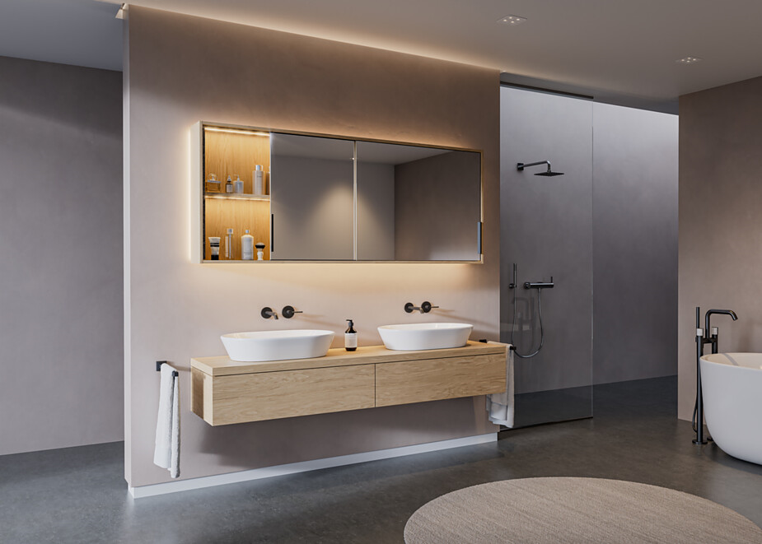 |  | 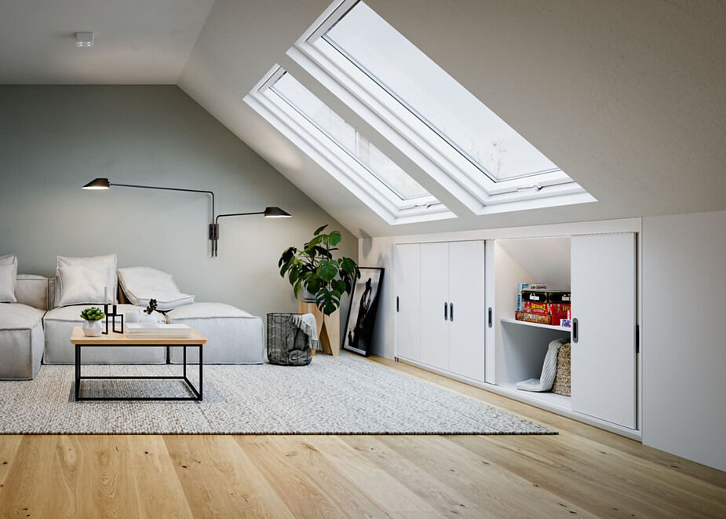

About Häfele
Maximising the value of space. Together.
Häfele is committed to developing liveable, sustainable room concepts for the living and working environments of tomorrow. Together with its partners, Häfele creates resource-saving, multifunctional solutions with maximum comfort.
Founded in 1923, the globally active specialist for intelligent hardware technology, electronic locking systems, lighting and networking offers its customers from over 150 countries unique 360° expertise. With a comprehensive product range, numerous services and a great deal of innovative spirit, the family-owned company is a reliable partner to its partners in the trade, furniture industry, retail and architecture - from brainstorming and planning to the implementation of their projects.
Over 8,000 employees, 38 subsidiaries and numerous other agencies around the world make up the team of the global player headquartered in Nagold in the Black Forest. The Group has been managed by Gregor Riekena since January 2023. Sibylle Thierer represents the interests of the shareholder families as Chairwoman of the Board of Directors. In the 2023 financial year, the Häfele Group achieved a turnover of 1.71 billion euros with an export share of 82%.
Further information can be found at www.haefele.de

QR-Code der Medieninformation


