Häfele press documents, interzum 2025
Inspiring, future-orientated concepts and an extensive portfolio of Häfele solutions and services – that is what to expect from the company at interzum 2025.
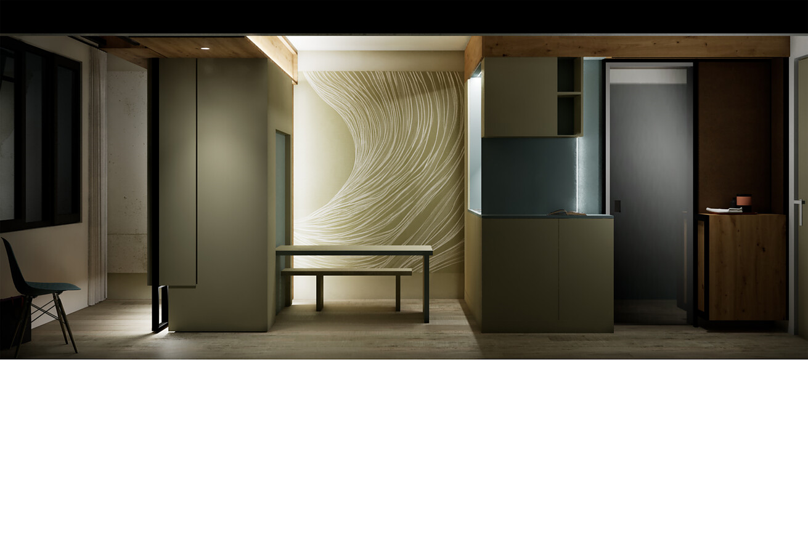

You will find extensive text and image material on the following topics in our press kit for interzum 2025:  Jointly developing liveable and sustainable spatial concepts for living and working environments  Häfele finds solutions for current and future room design requirements. Projects and solutions implemented by Häfele have one thing in common: they maximise the value of space. As such, the company’s entire trade fair approach is based on the Häfele purpose ‘Maximising the value of space. Together.’ But what does that mean in concrete terms?  Continue to the detailed media information  Häfele Lighting – The ideal symbiosis.  Häfele offers its partners a unique approach to design and planning with furniture and room lighting. After all, Häfele Lighting is the first and to date only brand to combine the application areas of “lighting in furniture” and “lighting in rooms” into an integrated and networked holistic experience. New Häfele Lighting products on show at interzum include the 24V lighting system OneCable and the new Häfele Lighting 24V High Efficiency LED strip lights.  Continue to the detailed media information  Newly developed Free Slim flap fitting  The team at the Flap Competence Center has completely redeveloped the revolutionary Free Slim flap fitting. With its innovative technology, it takes flap fittings to a new level in terms of slimness and efficiency. The Free Slim flap has already demonstrated its worth in practice with selected partners in the European furniture industry. Now it is time for the next chapter in the success story of Free Slim fittings.  Continue to the detailed media information  The new Slido F-Flush57 sliding fitting  The Slido F-Flush57 with flush-mounted design is brand new and the ideal solution for optimising space utilisation in furniture with minimum space requirements. This is because the innovative technology of the sliding fitting enables a flush design. It therefore offers not only functional, but above all aesthetic benefits for a wide range of applications in kitchens, offices, bathrooms and living rooms.  Continue to the detailed media information  The new Häfele Assedo – Electrical appliances for complete kitchens from a single source  Häfele’s electrical appliances set new standards in technology and design. With their elegant black finish, they blend harmoniously into any modern kitchen and marry a timeless appearance with functionality and durability. The Häfele Assedo range comprises ovens, microwaves, hobs, refrigerators, wine coolers, dishwashers and extractor hoods.  Continue to the detailed media information  Häfele connector expertise  To this day, Häfele is a true driver of innovation in the field of furniture connectors. Häfele’s latest solutions also address key issues of the future. They take into account the careful use of materials, the conservation of scarce resources and the holistic design of rooms. Häfele will be presenting connectors for minimised material thicknesses, such as the Minifix® 12, or the universal connector UC 16/64, which is one of Häfele’s latest developments.  Continue to the detailed media information  Please do not hesitate to contact us if you have any questions about press material:  Rainer Häupl  bering*kopal GbR, Büro für Kommunikation  T + 49 (0) 711 74 51 759-16  rainer.haeupl@bering-kopal.de  www.bering-kopal.de |  | Contact for journalists:  Rainer Häupl  bering*kopal GbR, Büro für Kommunikation  T + 49 (0) 711 74 51 759-16  rainer.haeupl@bering-kopal.de  www.bering-kopal.de  Contact in the company:  Sarah Grünler  Senior Corporate Communications Manager  Häfele SE & Co KG  Tel.: +49 (0)7452 95-510  Mobile: +49 160 97871786  sarah.gruenler@haefele.de

1 At interzum 2025, Häfele will be showcasing a series of completed projects for the first time, including the “Dynamic Living” project study. There is more to the company than just product innovations. In fact, their aim is to jointly develop customised, innovative solutions as part of co-creation and co-engineering projects, thereby creating added value and business opportunities for everyone involved. Figure: Häfele
1.
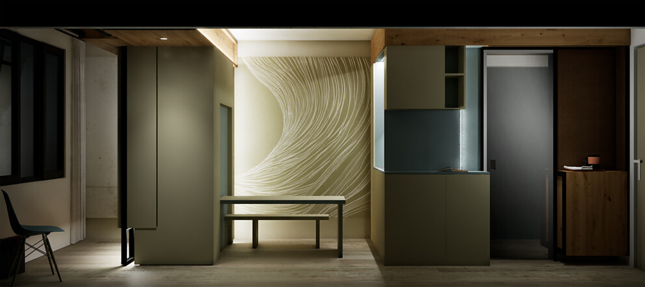

About Häfele
Maximising the value of space. Together.
Häfele is committed to developing liveable, sustainable room concepts for the living and working environments of tomorrow. Together with its partners, Häfele creates resource-preserving, multi-functional solutions with maximum convenience.
Founded in 1923, the globally operating specialist for intelligent hardware and fitting systems, electronic access control systems, lighting and networking provides its customers from over 150 countries with unique 360° expertise. With a comprehensive product range, numerous services and a considerable amount of innovative spirit, the family-run company is a reliable partner to joiners/cabinet makers, the furniture industry, dealers and architecture, from brainstorming and planning to the implementation of their projects.
More than 8,000 employees plus 38 subsidiaries and numerous other agencies around the world make up the team of the global player, with its headquarters in Nagold in the Black Forest. The Group has been managed by Gregor Riekena since January 2023. As the Chairperson of the Board of Directors, Sibylle Thierer represents the interests of the shareholder families. In the 2024 financial year, the Häfele Group achieved sales of 1.74 billion Euros with an export share of 82%.
Further information at www.haefele.de

QR code of the media information


