Visionary and service-oriented at interzum 2023
The "Häfele Discoveries" virtual showroom inspires with new content and impresses with an improved user experience.
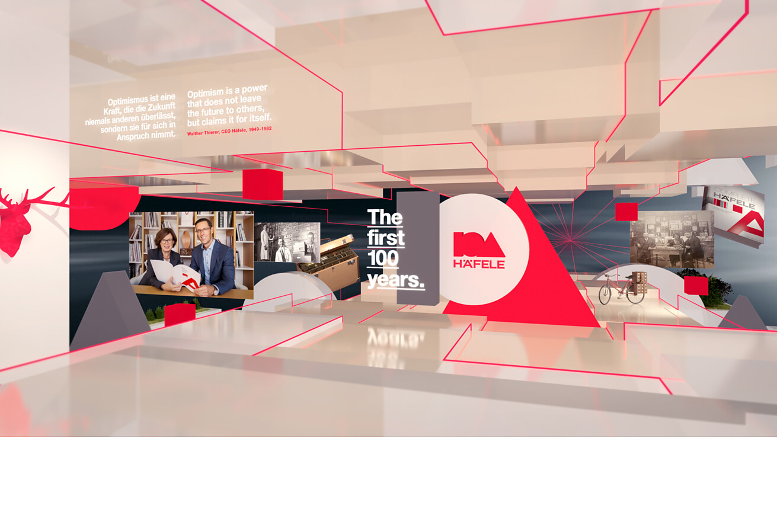
With immediate effect, the company is inviting you to an updated version of Häfele Discoveries. In virtual and amazingly realistic room scenarios, the specialist for intelligent hardware and fitting systems, lighting and electronic access control systems is showing a wide variety of lighting solutions and numerous products in use – in the form of a condensed highlight tour, among other things. And anyone who returns here to the real world with virtual inspiration will quickly find expert help in the Häfele Service+ product range: numerous experts simplify the everyday working life of Häfele partners and provide active support – from initial idea to installation.
Häfele Discoveries 2.0
The "Häfele Discoveries" virtual showroom was originally developed during the course of the Corona pandemic. For interzum, the three-dimensional. interactive discovery platform has undergone a comprehensive technical, content-related and visual update. It is innovative, contemporary and freely accessible 24/7 all over the world. From now on, registration is no longer required. You can get some inspiration there, obtain a great deal of additional information and still access the respective product detail page directly in the online shop with just a few clicks if you have discovered some specific requirements.
The platform is available in 33 different market versions and 18 languages. It has since won 13 awards, including the Red Dot Design Award, the UX Design Award and, most recently, the German Brand Award and the German Digital Award 2022.
The global showroom for your trouser pocket
From a thematic point of view, the Häfele Discoveries virtual showroom is based on the innovations at interzum 2023. In the welcome area, Gregor Riekena, who has been Häfele's new CEO since January 2023, now welcomes visitors with a compact overview of the contents. A special focus is on the staging of the theme world of light. Interactive buttons allow visitors to switch light sources on or off, and convey an amazingly real impression of space. During the trade fair there will also be live streams directly from the interzum in Cologne, which can also be experienced afterwards via the media library.
One platform – many application options
The virtual highlight tour of the virtual showroom leads visitors through different theme worlds in a descriptive way. You can find out what the Häfele innovations for 2023 are in just a few minutes here, and experience a wide variety of light scenarios and intelligent room solutions, among other things. Tobias Brenner, Head of Brand Communication at Häfele, explains that the digital discovery platform can be more than just an inspirational source of information: "With Häfele Discoveries, for example, a kitchen manufacturer can show its customers how a kitchen can look and feel with and without lighting in a very descriptive way. Ultimately, this can in turn have a positive effect on the purchasing decisions of their customers." The virtual showroom is therefore also a service for Häfele partners at the same time, and can be used for their discussions with end customers and provide them with concrete purchasing arguments, for example.
Together with concentrated light competence
It is no coincidence that the Service+ area is situated close to the Light area on the Häfele trade fair booth at interzum 2023. The topic of light has been completely rethought by Häfele. Light shapes rooms, furniture and functional areas, accentuates zones, puts the furniture in the limelight both inside and out, and creates atmosphere. A wide range of applications such as this requires experts and competent support. Under the motto of "We'll do it together!", Häfele offers its partners an all-round carefree service along the entire work process. Starting with knowledge transfer and individual light planning, to custom-made lights from a quantity of 1, and also programming and installation.
Making life easier: Service+ for measurable successes
At interzum 2023, the comprehensive Service+ product range will be consistently demonstrated on the basis of the focus topic of light. The Häfele experts therefore become an integral part of the teams at their local Häfele partners. The goal is to save partners valuable time and relieve the strain on them as much as possible: "Numerous Häfele experts are there for our partners worldwide almost 24/7 in order to find a solution that is tailored to their individual needs. This starts with creative brainstorming and competent advice, and extends to commissioning on site at the customers of our customers if necessary", says Tobias Brenner, Head of Brand Communication at Häfele, summarising the Service+ range of services.
The Service+ services are basically divided into four areas:
1. Inspiration and transfer of expertise
2. Individual planning
3. Customised solutions
4. Assembly and installation
Within the various areas of the Häfele trade fair booth in Cologne, the analogue and virtual worlds will be cross-connected via QR codes. With a tap of their smartphone, visitors to the trade fair will also be able to experience the relevant theme worlds such as kitchen, caravan or office directly in the virtual showroom – or make a note of them for the period after the hustle and bustle of the trade fair. This closes the circle between Häfele's analogue and virtual range of services.
Link:
Häfele Discoveries website
Häfele Service+ website
Nagold, May 2023
Reprint free of charge / Please send a copy
Company contact person:
Sarah Grünler
Brand Communications ∙ PR-Managerin
Häfele SE & Co KG
Tel.: +49 (0)7452 95-510
sarah.gruenler@haefele.de
1 It will be easier for everyone to access from now on: the multiple award-winning virtual showroom Häfele Discoveries is being given a comprehensive update for interzum. It will provide exciting trade fair insights, not only during but also after interzum. Illustration: Häfele
2 Inspirational: The Häfele Discoveries virtual showroom has been redesigned. Visitors can experience Häfele's new products virtually around the clock. Illustration: Häfele
3 We'll do it together! Häfele provides its partners with a wide range of services – for individual light and room acoustics planning, for example. Illustration: Häfele
4 The Häfele Academy provides a wide range of training courses on the subject of lighting, from entry level to light professionals. Illustration: Häfele
1.2.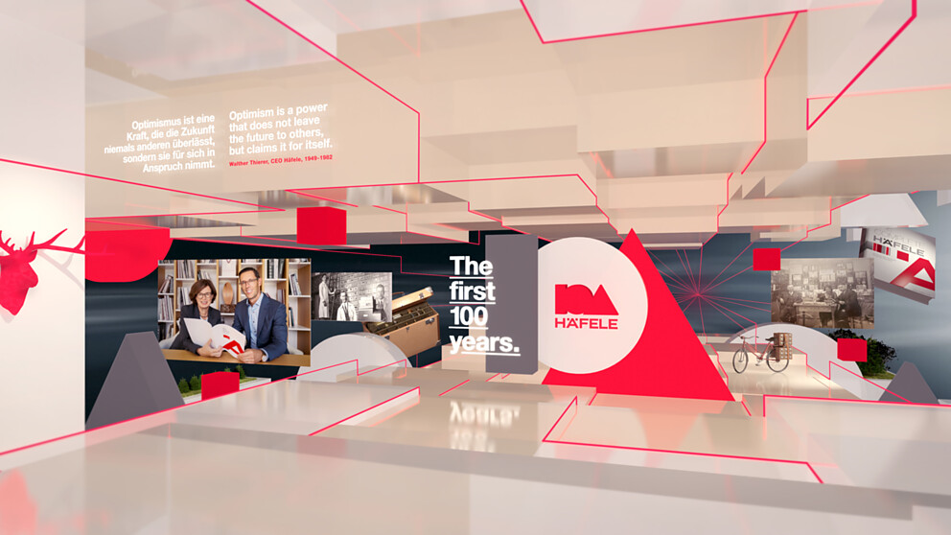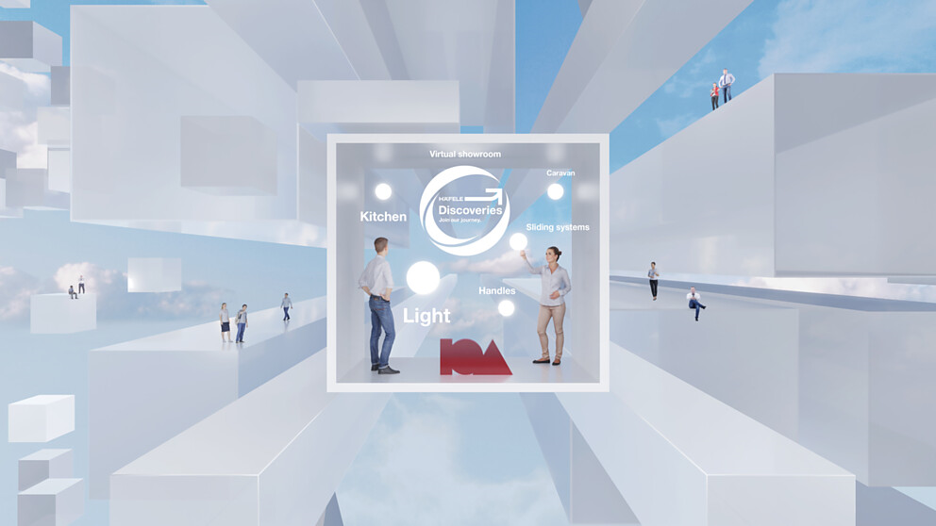3.4.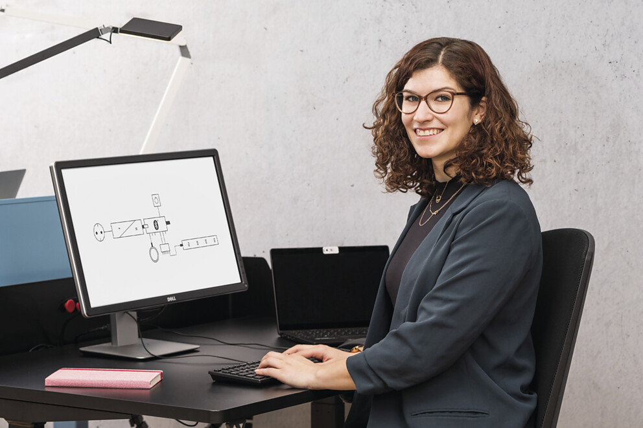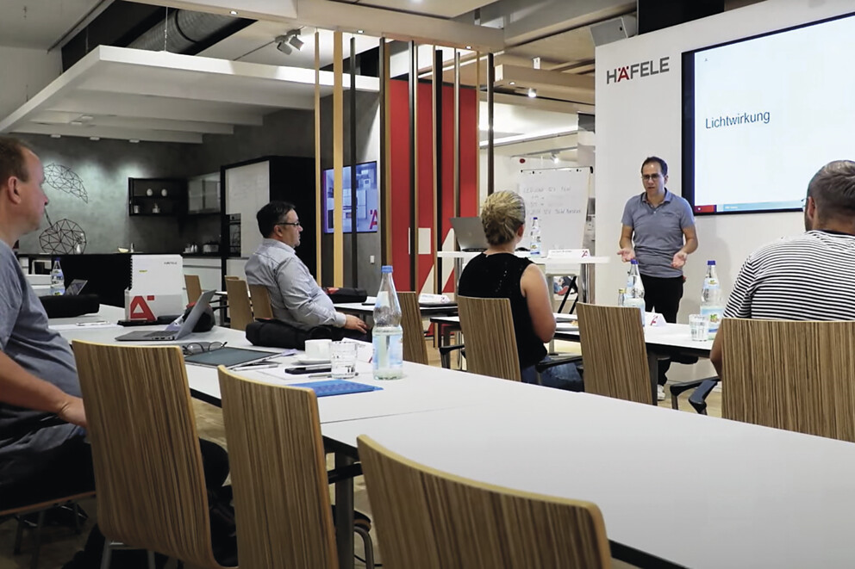
About Häfele
Häfele. The first 100 years.
Innovative strength, courage and optimism: these are qualities which have accompanied Häfele from the very beginning and have already distinguished the founders, merchants Adolf Häfele and Hermann Funk, who established Häfele in 1923 as a specialist hardware shop near Nagold. This valued contact point for the carpentry trade has now become a global company, Häfele SE & Co KG, with subsidiaries in 38 countries and more than 8000 employees. In the 2022 financial year, the Häfele Group achieved sales of 1.87 billion Euros with an export share of 81%.
Nagold is still the headquarters of the international Häfele Group, which has developed into the leading expert for hardware and fitting systems, electronic access control systems and LED lighting over the decades. The furniture industry and also architects, joiners/cabinet makers and dealers from more than 150 countries rely on the expertise of the innovative family business, which has been under the management of Gregor Riekena since January 2023.
The anniversary year is characterised by both the origins and the look into the future: Häfele is celebrating its first 100 years in a fitting manner – in Nagold and in selected locations worldwide.
Further information at www.haefele.de

QR-Code der Medieninformation


