All-round carefree: holistic solutions for kitchens
Design, use of space and ease of assembly are the top priorities with Häfele kitchen solutions
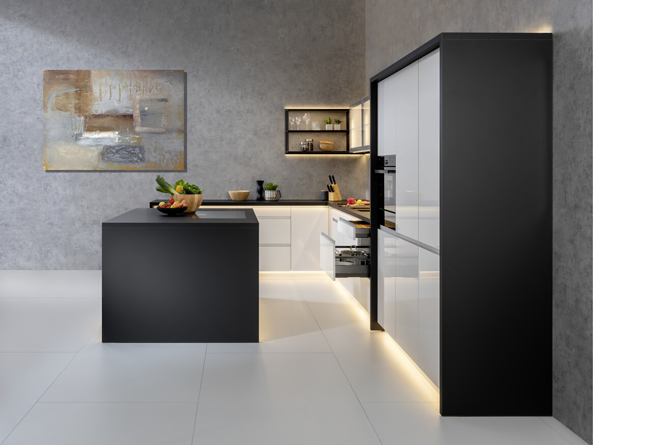
When living areas are merging with each other in an increasing number of cases and spaces are being used for different purposes, clever solutions are needed. Häfele, the specialist for intelligent hardware and fitting systems, lighting and electronic access control systems, supports its customers in using areas sensibly, combined with an appealing design and suitable lighting scenes. The extensive kitchen range from Häfele makes it possible to find suitable solutions for a wide variety of customer requirements and ideas.
At interzum 2023, the company will be presenting comprehensive solutions for the kitchen. As well as the Häfele Matrix drawer systems, these also include waste separation systems or the sliding solutions from the Häfele Slido product range. The range of kitchen equipment is rounded off with products from the Häfele household appliance series, the Häfele H23 handle collection or the Alusplash splashback and wall panel.
Everything in the box – for every need, every application, and every requirement
Häfele Matrix is Häfele's own house assortment of drawers and runners. The Häfele Matrix Runner drawer runners are available as roller runners, ball bearing runners or concealed runners. They all have very good running characteristics, and are easy to install. With the Matrix drawer side runner systems, customers can choose between the Häfele Matrix Box P premium double-walled drawer side system, the Häfele Matrix Box Slim A thin-walled drawer side system and the Häfele Matrix Box S basic double-walled drawer side system.
All of these are equipped with high-quality full extensions with a self and soft closing mechanism or the Push-to-open opening mechanism, and are available in all of the most popular nominal lengths and in different colours. The trend for drawer applications with high, closed drawer sides has continued. The Matrix Box P with a drawer side height of 180 mm and integrated tilt adjustment for the front panels is therefore completely new in the product range.
Matrix Extra, the product range for suitable interior equipment, includes a range of accessory products for all Matrix drawer elements.
Separation, completely uncomplicated: the Häfele waste separation system
Häfele now also has a customisable waste separation system for fitting into pull-out systems. The Häfele waste separation system is available in three different heights so that it will fit into any normal commercial pull-out drawer. An adjustable latching system connects several containers together and gives them support – regardless of the drawer type or the side panel thickness. Customers can choose between seven different container variants, plus two additional storage drawers or a suitable steel lid for the top closure in the cabinet. Each container has its own lid for sealing and a tensioning frame for easy attachment of waste bags. Häfele also provides an easy-to-assemble and easy-to-operate model for waste bins behind hinged doors.
Exclusive Häfele series for kitchen electrical appliances
Häfele will be presenting its new exclusive Häfele series for kitchen electrical appliances at Interzum 2023. The new own-house assortment rounds off the portfolio for giving rooms a holistic design. Advice and services for the range of electrical appliances are seamlessly integrated into the overall logistics and higher-level services.
Put it in your pocket: more free space thanks to Slido F-Park pocket door solutions
Slido F-Park creates more free space and clarity in the kitchen. The pivot sliding system stores large kitchen front elements or doors at the side of the cabinet, and provides smooth opening and soft closing. The sliding door fittings of the product series are supplied pre-mounted together with the front elements or door elements. This means simple and quick assembly and therefore significant time and money savings. In the new Slido F-Park71 25B variant, the doors disappear into a pocket, creating more space and order in the room.
Häfele theme worlds at interzum and in the virtual showroom
All of the product worlds and the corresponding services that are available from Häfele are intended to make things easy for the customer and provide the maximum amount of benefit. Häfele's wide range of products significantly streamlines planning logistics, and therefore provides clear added value in the industrial or handicraft development and production of furniture and room concepts. The theme worlds on the Häfele trade fair booth range from lighting and kitchen solutions to caravanning, hospitality, office and design.
You can also discover the Häfele cosmos in the Häfele Discoveries virtual showroom – now without registration and with lots of interesting additional information.
Link to the Häfele Discoveries
Nagold, may 2023
Reprint free of charge / Please send a copyCompany contact person:
Sarah Grünler
Brand Communications ∙ PR-Managerin
Häfele SE & Co KG
Tel.: +49 (0)7452 95-510
sarah.gruenler@haefele.de
1 Almost the entire kitchen equipment can be designed from a single source with Häfele. As part of Häfele's own house assortment of Matrix drawers and runners, the Matrix Box P with a drawer side height of 180 mm and integrated tilt adjustment for the front panels is new to the product range. Photo: Häfele
2 An adjustable latching system connects several containers together in the brand new Häfele waste separation system and provides them with support, regardless of the drawer type or the side panel thickness. Three different heights and seven container variants give the system additional flexibility and make it universally usable. Figure: Häfele
3 Attractive appearance and unique features: The wide-ranging assortment of Häfele's new line of kitchen electrical appliances includes about forty electrical appliances covering all areas: Baking, cooking, sinks, refrigeration, wine cooling and extractor hoods. Customers benefit from the consistently excellent price-performance ratio, the 5-year full warranty and the reliable Häfele service. Photo: Häfele
4 More space in rooms: The new Slido F-Park71 25B variant from Häfele's well-tried Slido sliding solution product range allows large front elements to disappear unobtrusively into a pocket at the side of the cabinet – for even more freedom of movement and clear lines in the room. Photo: Häfele
1.2.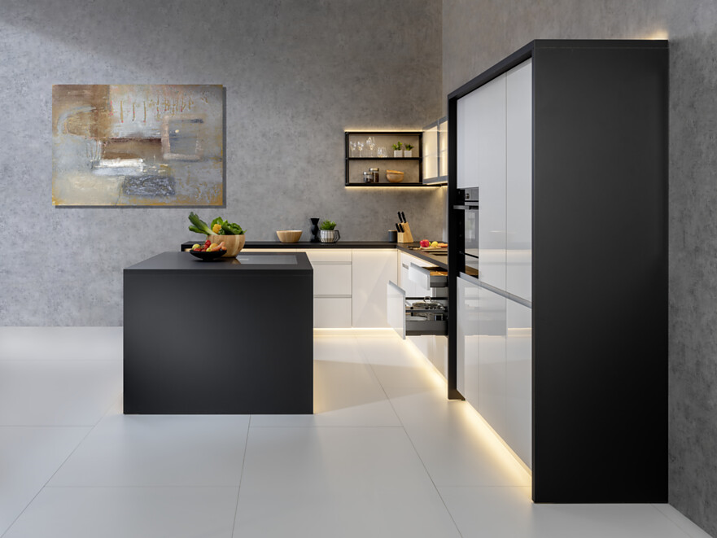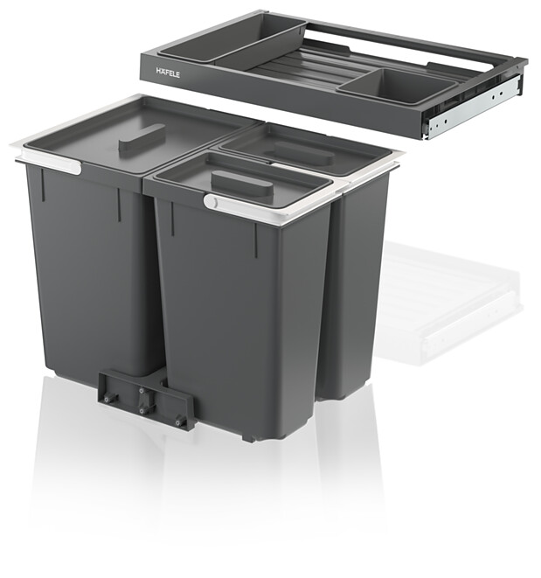3.4.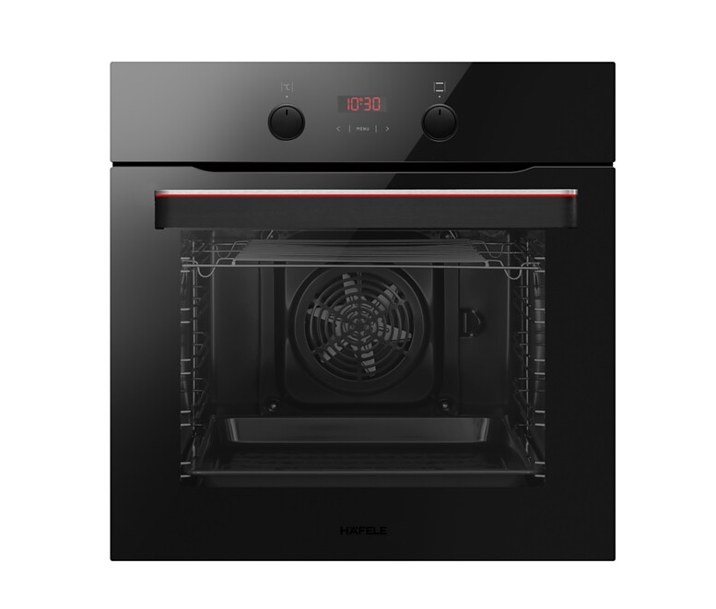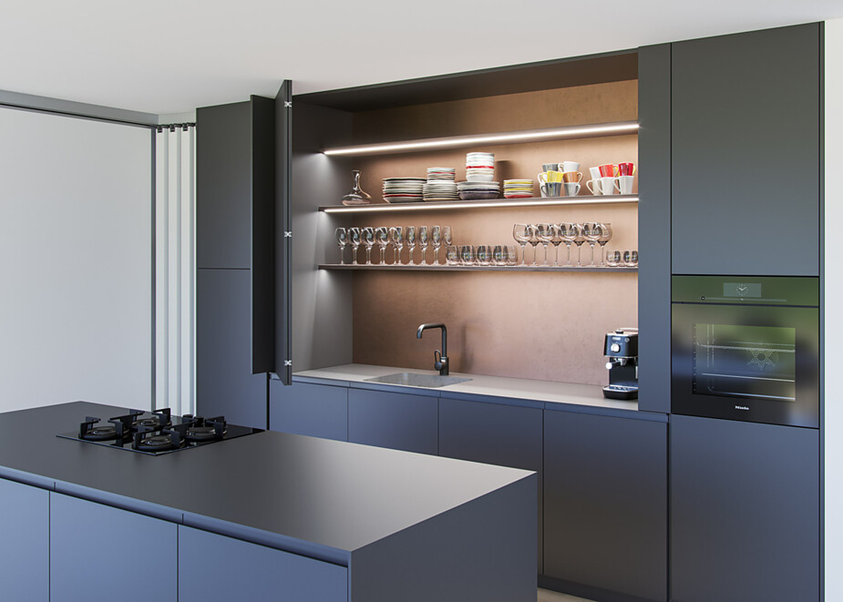
About Häfele
Häfele. The first 100 years.
Innovative strength, courage and optimism: these are qualities which have accompanied Häfele from the very beginning and have already distinguished the founders, merchants Adolf Häfele and Hermann Funk, who established Häfele in 1923 as a specialist hardware shop near Nagold. This valued contact point for the carpentry trade has now become a global company, Häfele SE & Co KG, with subsidiaries in 38 countries and more than 8000 employees. In the 2022 financial year, the Häfele Group achieved sales of 1.87 billion Euros with an export share of 81%.
Nagold is still the headquarters of the international Häfele Group, which has developed into the leading expert for hardware and fitting systems, electronic access control systems and LED lighting over the decades. The furniture industry and also architects, joiners/cabinet makers and dealers from more than 150 countries rely on the expertise of the innovative family business, which has been under the management of Gregor Riekena since January 2023.
The anniversary year is characterised by both the origins and the look into the future: Häfele is celebrating its first 100 years in a fitting manner – in Nagold and in selected locations worldwide.
Further information at www.haefele.de

QR-Code der Medieninformation


