Häfele provides light solutions for furniture and rooms from a single source
Dynamic light sources support multifunctional use of rooms
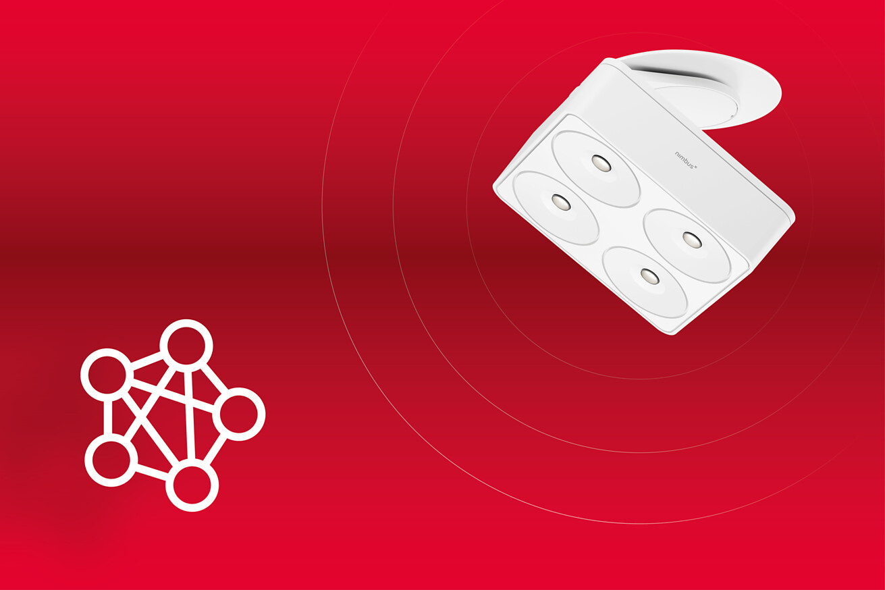
The demands made of living spaces have changed significantly due to modern, open architectural concepts. Different usage situations in a room require dynamic, individual light concepts in order to support the respective function of the room in an ideal way. Häfele, the specialist for intelligent hardware and fitting systems, lighting and electronic access control systems, brings light, furniture and rooms together. The simple and flexible overall solutions can be experienced in practical applications and the effect thereof brought to life at Interzum 2023.
Häfele is demonstrating once again how valuable a well thought-out interplay of furnishing and lighting is. As a light professional, the company supplies products and systems which allow every joiner/cabinet maker to implement complex concepts with ease. At the same time, Häfele pays attention to easy handling for the end customer.
Beautifully smart: Nimbus lights from the Häfele product range now with Häfele Connect Mesh
Five Nimbus light families from the Häfele product range are now available in smart versions. They visually correspond with each other, and are all suitable for both the project sector and for private living. Each individual light is equipped with a Connect Mesh Chip. With simple plug and play, it becomes part of the Häfele Connect Mesh system and can be individually programmed to interact with other lights. From shops to offices, hotels or private homes: Light scenarios which fulfil different requirements can be defined in advance. Whether it is a matter of very lifelike colour rendering, a concentrated working atmosphere, atmospheric light, or day and night lighting - each Nimbus light with Connect Mesh capability and therefore the entire light experience in the room can be individually adjusted.
Good (light) mood pre-programmed: Refresh for Häfele Connect App 2.0
The programmed light scenarios can be controlled via Häfele Connect App 2.0, which has been given a refresh for even more ease of handling at interzum. Either via the smartphone – or the scenarios are stored directly on the light switch or in a remote control. The app can also integrate other Häfele products, such as electric sliding systems, locks or flaps, which is an advantage in areas such as hospitality or retail. The modernised app puts even more emphasis on being user-friendly and having a self-explanatory procedure – making operation child's play for every joiner/cabinet maker and also for users.
On the floor or the surface, and in the furniture: Loox 5 brings enlightenment to the "heart of the home"
Functionality in perfection, but also a pleasant atmosphere in the room - Häfele presents new light products from its Loox 5 series for the kitchen to fulfil both requirements. The Häfele product range now includes a spot lighting option with the dimmable LED 210x (12V) / 310x (24V) plinth lights. They set accents, and are available in white, grey or black to match the rest of the furniture design. Häfele also supplies the 5111 plinth profile, into which linear lighting with Häfele Loox strip lights can be integrated. Functional light is provided where it is needed by the slim kitchen surface-mounted downlight LED 2100 (12V) / 3100 (24V) in black or silver. Particularly practical above the worktop: it can be operated using a gesture sensor. Häfele has also thought about light in furniture: with its easy-to-install LED 2110 (12V) / 3110 (24V) drawer light with automatic on/off switch via a sensor, even the most distant corner in drawers is illuminated. Häfele is therefore presenting an all-round light product range for the "heart of the home" – flanked by other products such as new sensors, distributors and accessories to accompany the well-tried Häfele Loox 5 family.
Häfele theme worlds at interzum and in the online brand world
All of the product worlds and the corresponding services that are available from Häfele are intended to make things easy for the customer and provide the maximum amount of benefit. Häfele's wide range of products significantly streamlines planning logistics, and therefore provides clear added value in the industrial or handicraft development and production of furniture and room concepts. The theme worlds on the Häfele trade fair booth range from lighting and kitchen solutions to caravanning, hospitality, office and design.
You can also discover the Häfele cosmos in the Häfele Discoveries online brand world – now without registration and with lots of interesting additional information.
Link to Häfele Discoveries
Nagold, may 2023
Reprint free of charge / Please send a copyCompany contact person:
Sarah Grünler
Brand Communications ∙ PR-Managerin
Häfele SE & Co KG
Tel.: +49 (0)7452 95-510
sarah.gruenler@haefele.de
1 Five Nimbus light families from the Häfele product range are now available in smart versions, including the Nimbus Q Four Connect Mesh. As part of the Häfele Connect Mesh system, they can easily be individually programmed in interaction with other lights. Photo: Häfele
2 Be it functional work light or atmospheric feel-good light - each Connect Mesh-capable light from Nimbus, and therefore the entire light experience in the room, can be individually adjusted. Photo: Häfele
3 The Häfele Connect App 2.0 will have even more convenient handling and a modern look at interzum. Photo: Häfele
4 Programmed light scenarios can be controlled by smartphone or using other terminal devices and also incorporate electric sliding systems, locks or flaps from Häfele if required. Photo: Häfele
1.2.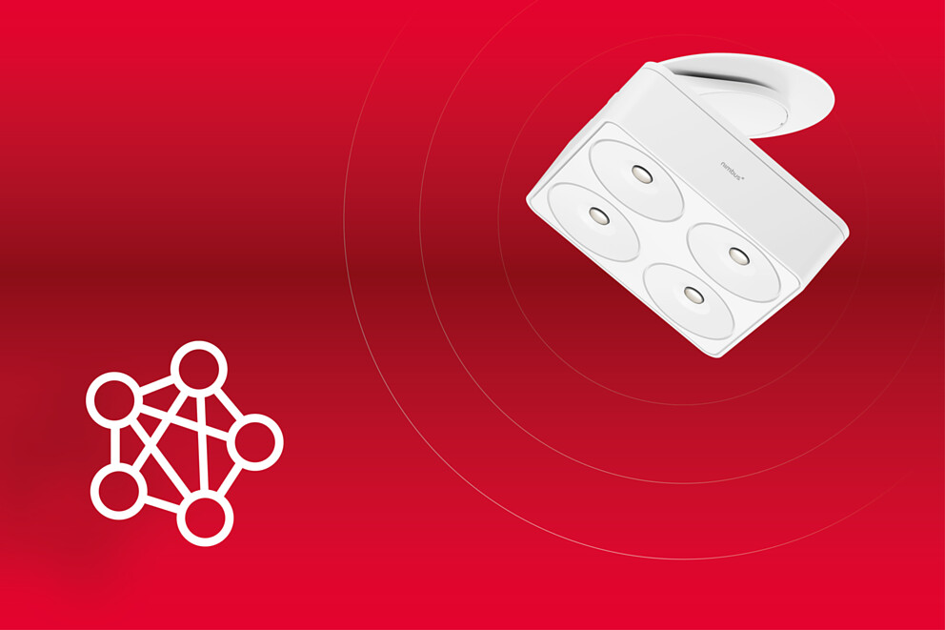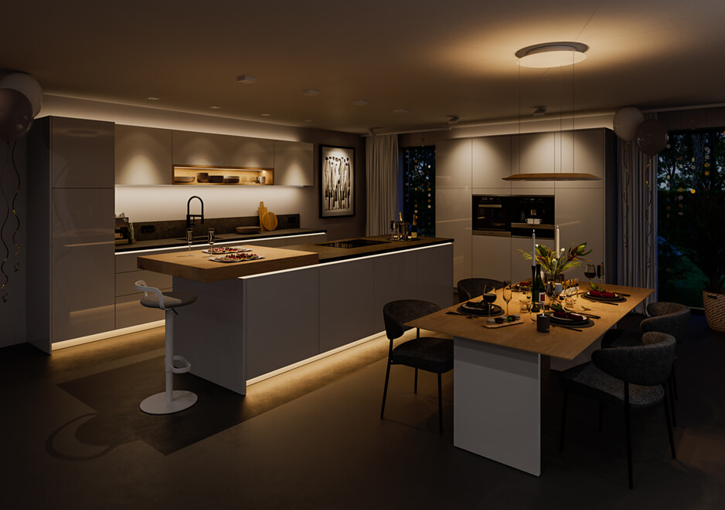3.4.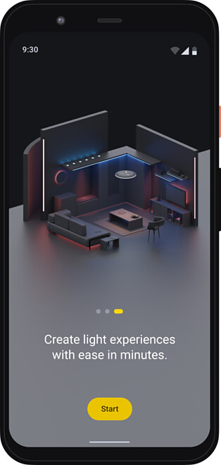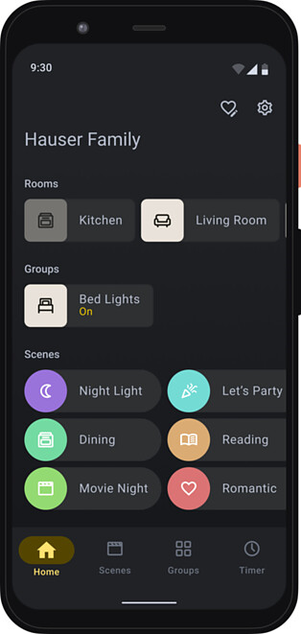
5 The best basis: light in the kitchen plinth as a design element for the heart of the house. The dimmable LED 210x (12V) / 310x (24V) plinth lights provide spots of light. Figure: Häfele
6 Häfele Loox LED light strips for indirect diffused light can be integrated and concealed in the new 5111 plinth profile. Figure: Häfele
7 Freely designable: The light shades of Häfele's new "Bed Light" product can also be printed – with a hotel logo, in a CI-compliant colour or with a special pattern. This makes the rotatable lights, which have a USB port for charging mobile devices, an individual eye-catcher. Figure: Häfele
5.6.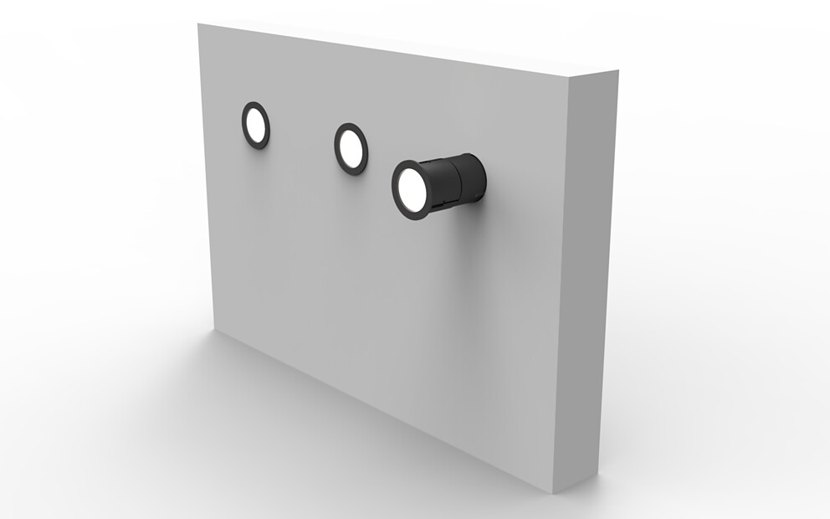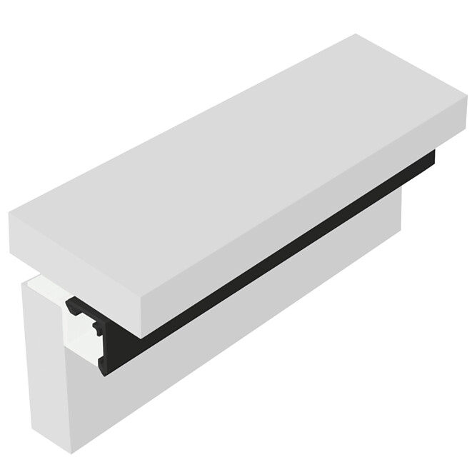7.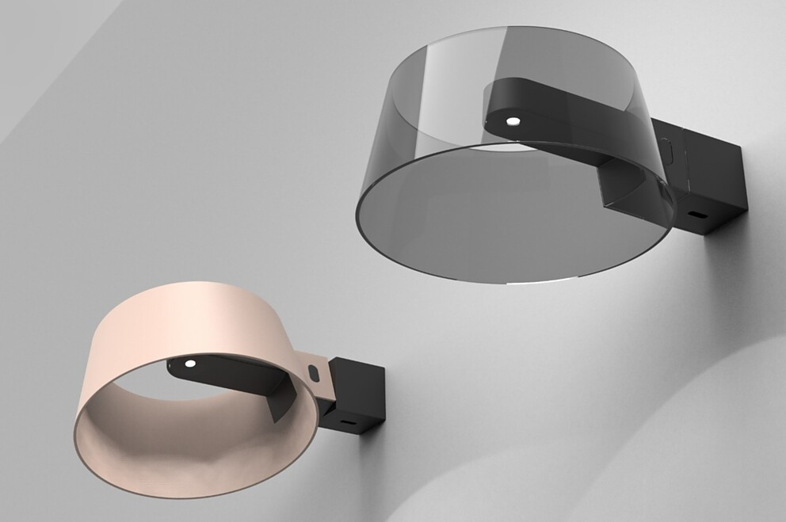
About Häfele
Häfele. The first 100 years.
Innovative strength, courage and optimism: these are qualities which have accompanied Häfele from the very beginning and have already distinguished the founders, merchants Adolf Häfele and Hermann Funk, who established Häfele in 1923 as a specialist hardware shop near Nagold. This valued contact point for the carpentry trade has now become a global company, Häfele SE & Co KG, with subsidiaries in 38 countries and more than 8000 employees. In the 2022 financial year, the Häfele Group achieved sales of 1.87 billion Euros with an export share of 81%.
Nagold is still the headquarters of the international Häfele Group, which has developed into the leading expert for hardware and fitting systems, electronic access control systems and LED lighting over the decades. The furniture industry and also architects, joiners/cabinet makers and dealers from more than 150 countries rely on the expertise of the innovative family business, which has been under the management of Gregor Riekena since January 2023.
The anniversary year is characterised by both the origins and the look into the future: Häfele is celebrating its first 100 years in a fitting manner – in Nagold and in selected locations worldwide.
Further information at www.haefele.de

QR-Code der Medieninformation


