Unique design and functionality
Häfele presents new Free slim family of flap fittings.
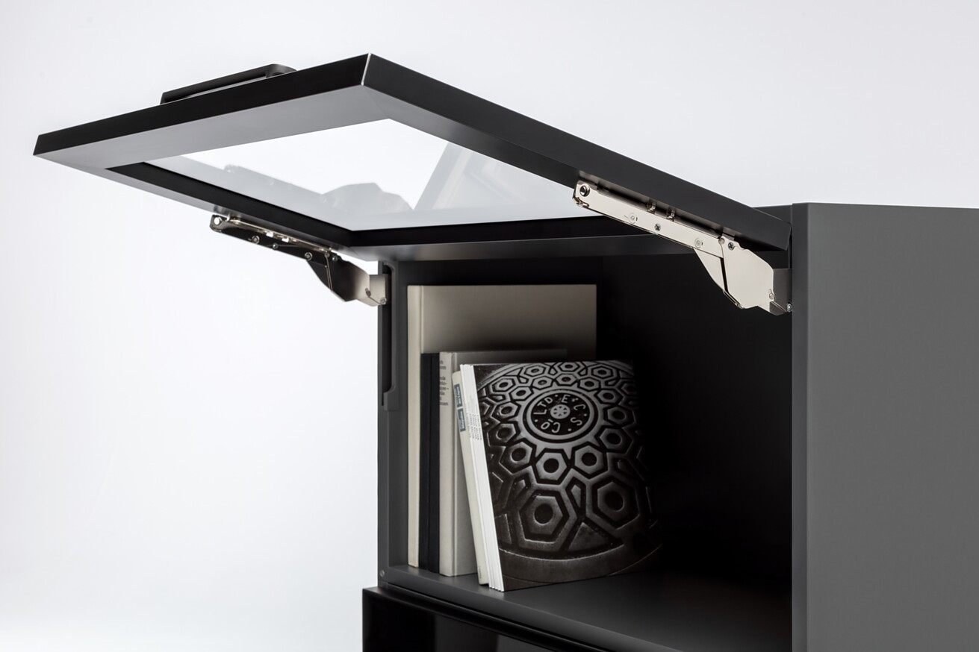
In a completely re-thought approach to technology, Häfele has developed a hardware system that is unique in terms of both design and functionality. The usual high level of performance and comfort that customers are already familiar with from the existing Free product family is also provided by the innovative Free slim flap fitting.
Slim systems – more room
Slim systems are also establishing themselves in the fittings area. Purist design not only has aesthetic advantages, but also from an economic and sustainability point of view. Reducing the number of variants while maintaining the same scope of functionality, in conjunction with slim geometries, conserves resources along the entire value creation chain from production to the consumer.
Invisible revolution: the innovative Free slim flap fitting
Things are all the better if an important extra emerges at the same time: With the Free slim flap fitting from Häfele, it consists of more space and design in the furniture. Free slim is a hardware system with a minimalist design. Thanks to its extremely slim design and the possibility of integrating it directly into the cabinet wall, it increases the storage space volume of furniture to the maximum, therefore putting furniture design and the impression of movement in the foreground.
Häfele's development engineers have developed a flexible modular solution using a newly conceived technological approach. All of the most popular opening types, flap sizes and flap weights are covered by just a few hardware variants for applications with or without a handle. The fittings, which have a slim housing that is just eight millimetres in size, can be used on the right or the left. They are either conventionally screwed onto the side panel or integrated almost invisibly into it. By request, the fittings can be supplemented with an innovative slimline electric drive with integration into the Häfele Connect Mesh system. Different lever arms make it possible for a standard lift mechanism to be converted into a double flap lift-up fitting, lift up front fitting or lift up flap fitting. Häfele's first selected industrial partners will be starting to use Free slim from the end of this year.
Häfele theme worlds at interzum and in the virtual showroom
All of the product worlds and the corresponding services that are available from Häfele are intended to make things easy for the customer and provide the maximum amount of benefit. Häfele's wide range of products significantly streamlines planning logistics, and therefore provides clear added value in the industrial or handicraft development and production of furniture and room concepts. The theme worlds on the Häfele trade fair booth range from lighting and kitchen solutions to caravanning, hospitality, office and design.
You can also discover the Häfele cosmos in the Häfele Discoveries virtual showroom – now without registration and with lots of interesting additional information.
Link to Häfele Discoveries
Nagold, may 2023
Reprint free of charge / Please send a copyCompany contact person:
Sarah Grünler
Brand Communications ∙ PR-Managerin
Häfele SE & Co KG
Tel.: +49 (0)7452 95-510
sarah.gruenler@haefele.de
1 You'll see that you can't see anything: The Free slim flap fitting from Häfele is a technical revolution. Free slim can be integrated into the side panels of tall cabinets almost invisibly and without losing space. Figure: Häfele
2 Maximum storage space in furniture thanks to innovative technology: only a few variants of the same slimline fitting cover all of the most popular flap solutions. Figure: Häfele
3 Free slim can be integrated into the side panels of tall cabinets almost invisibly and without any loss of space. Figure: Häfele
1.2.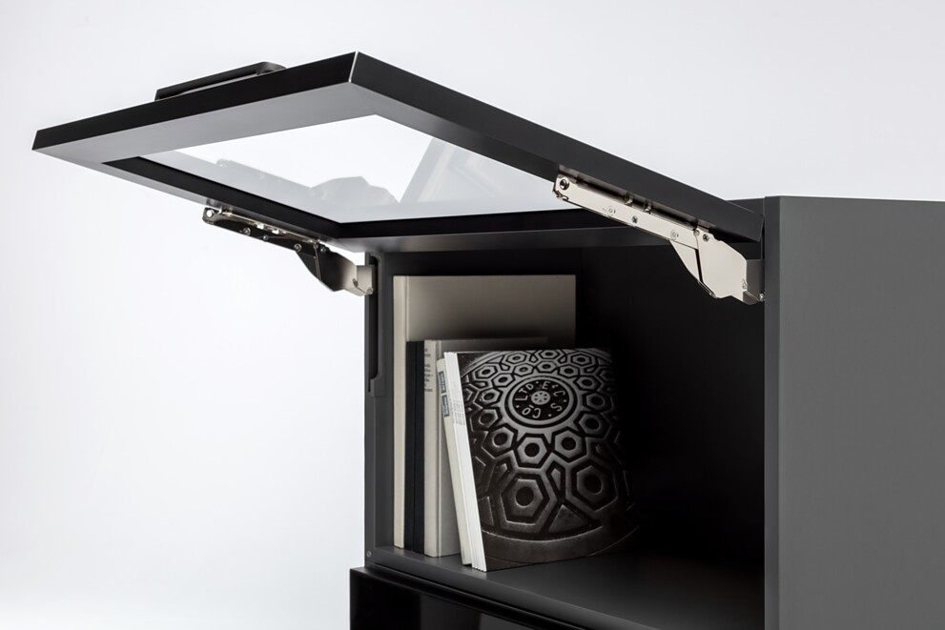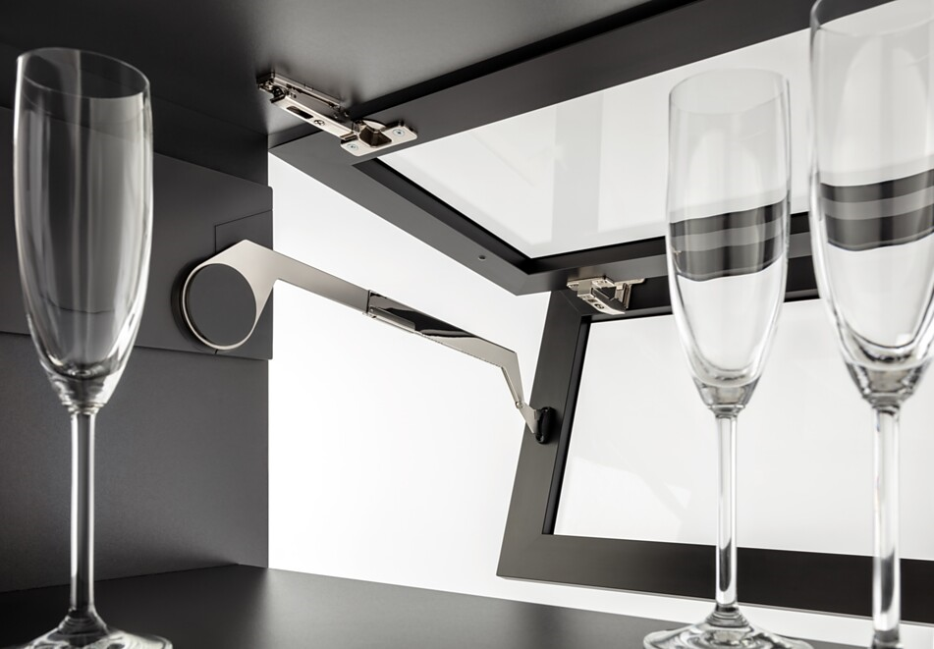3.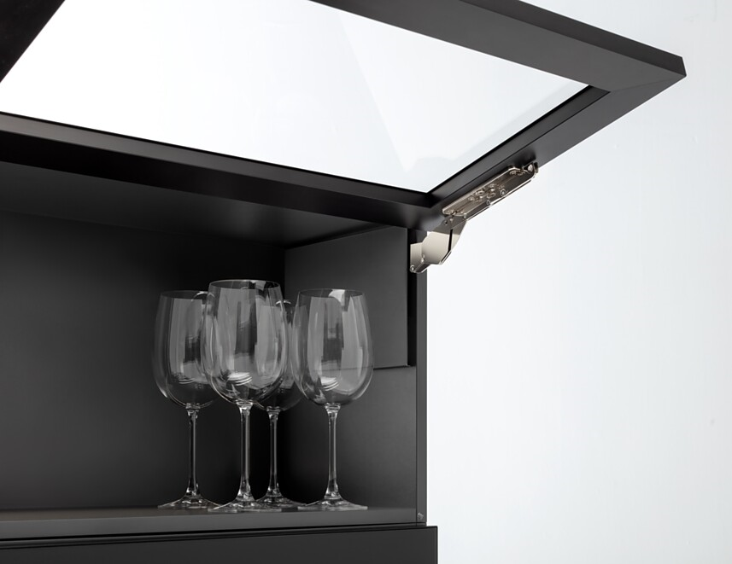
About Häfele
Häfele. The first 100 years.
Innovative strength, courage and optimism: these are qualities which have accompanied Häfele from the very beginning and have already distinguished the founders, merchants Adolf Häfele and Hermann Funk, who established Häfele in 1923 as a specialist hardware shop near Nagold. This valued contact point for the carpentry trade has now become a global company, Häfele SE & Co KG, with subsidiaries in 38 countries and more than 8000 employees. In the 2022 financial year, the Häfele Group achieved sales of 1.87 billion Euros with an export share of 81%.
Nagold is still the headquarters of the international Häfele Group, which has developed into the leading expert for hardware and fitting systems, electronic access control systems and LED lighting over the decades. The furniture industry and also architects, joiners/cabinet makers and dealers from more than 150 countries rely on the expertise of the innovative family business, which has been under the management of Gregor Riekena since January 2023.
The anniversary year is characterised by both the origins and the look into the future: Häfele is celebrating its first 100 years in a fitting manner – in Nagold and in selected locations worldwide.
Further information at www.haefele.de

QR-Code der Medieninformation


