Press documents for Häfele, interzum 2023
A whole universe of new products, great services, a fresh online showroom and a retail reference – the trade fair news for the interzum 2023 in Häfele’s 100th anniversary year.
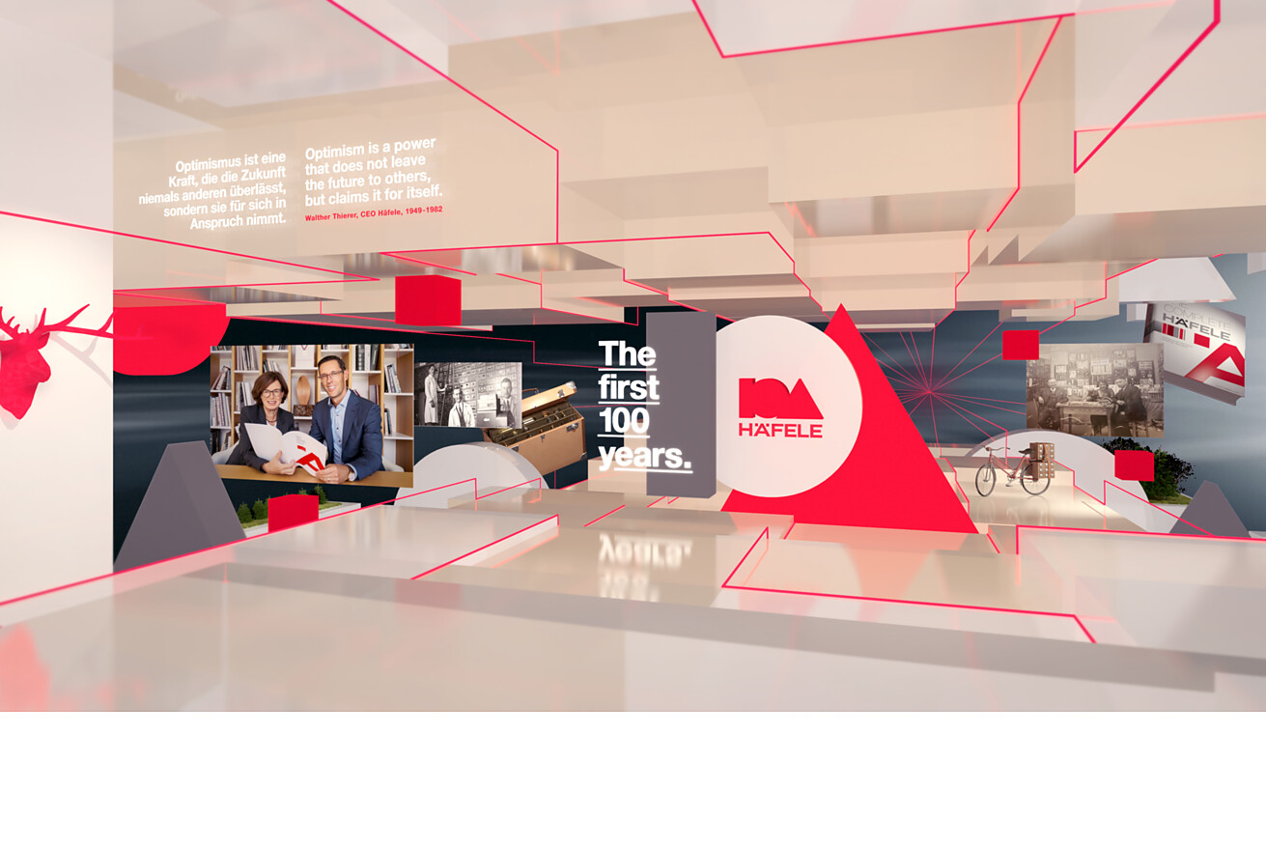

“Häfele is at an interesting intersection between the first and second centuries of its corporate history. For more than a year, we have been working intensively on the next chapter in the company's history. At the interzum in May, we will show where our journey is heading together with our customers," says Gregor Riekena, Häfele's new CEO since January 2023.  In our press kit for the interzum 2023, you will find extensive text and image material on Häfele's new products and services, a courageous look into the future and at the company's activities in its 100th year. Anniversary year and a charming reference.  Light and networking product innovation  Dynamic, customised lighting concepts are made possible by Häfele's complete solutions. They make multifunctional use of space possible – simple and flexible to install, convenient to operate by the end customer.  Continue to the detailed media information  Innovative Free slim flap fitting  The extremely compact Häfele Free slim is nothing less than a revolution in the field of flap fittings. Thanks to the extremely slim design and the option of integrating the fittings directly into the cabinet wall, the Free slim increases the storage space volume of furniture to the maximum. At the same time, the logistics and the consumption of resources are reduced.  Continue to the detailed media information  Product innovations for holistic kitchen concepts  Holistic kitchen concepts from a single source: from the clever waste separation system to Häfele’s own Matrix range of drawers and runners, the Slido F-Park71 25B pocket door sliding solution for a tidy design of large-format kitchen fronts and exclusive Häfele series for electrical kitchen appliances. Häfele will be presenting sophisticated kitchen concepts at the interzum 2023.  Continue to the detailed media information  Innovative Häfele Discoveries and Service+  You can’t be at the interzum? Not a problem, because you can also see Häfele’s new products, the trade fair booth and the live stage online: the interactive and three-dimensional Häfele Discoveries platform, which has just been revised, is freely accessible around the clock and worldwide. Häfele’s extensive Service+ range can be found in the online showroom in addition to the trade fair booth.  Continue to the detailed media information  Anniversary portrait on the occasion of the 100th birthday  On the occasion of its 100th anniversary, Häfele has many things in the pipeline. A visionary project has been launched with the construction of the “Dynamics Centre” in Nagold – and Häfele’s future path is going to be presented at numerous events for the interzum or at the Nagold site. Take a look at Häfele's exciting past and promising future.  Continue to the detailed media information  Reference report for lighting at Lechtaler Dirndl & Tracht  Far removed from the “yodelling look,” Häfele helped a carpenter plan the intelligent networked lighting of a specialist shop for traditional costume fashions and supplied the necessary products.  Continue to the reference report  Other language versions of the Häfele press kit for the interzum 2023  - Häfele dossier de prensa interzum 2023 (ES)  - Häfele mappa della stampa interzum 2023 (IT)  - Häfele communiqué de presse interzum 2023 (FR)  Please do not hesitate to contact us if you have any questions about press material:  Rainer Häupl  bering*kopal GbR, Büro für Kommunikation  T + 49 (0) 711 74 51 759-16  rainer.haeupl@bering-kopal.de  www.bering-kopal.de |  | Company contact person:  Sarah Grünler  Brand Communications ∙ PR-Managerin  Häfele SE & Co KG  Tel.: +49 (0)7452 95-510  sarah.gruenler@haefele.de

1 Figure: Häfele
1.
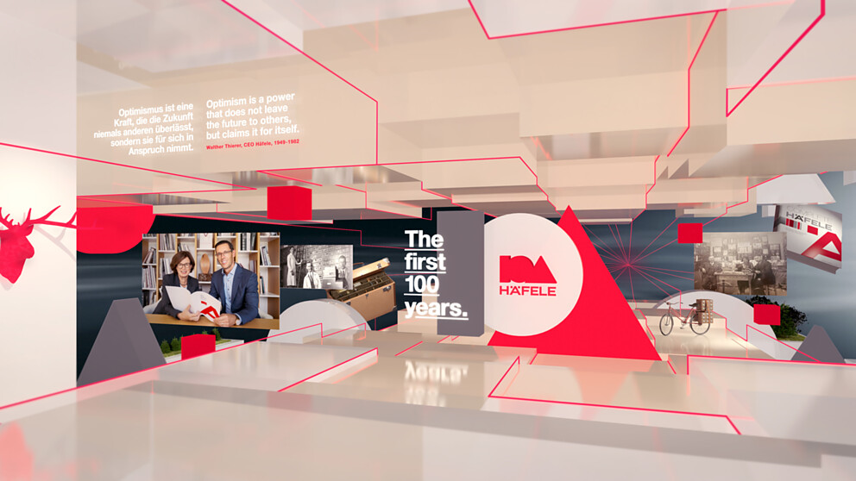

About Häfele
Häfele. The first 100 years.
Innovative strength, courage and optimism: these are qualities which have accompanied Häfele from the very beginning and have already distinguished the founders, merchants Adolf Häfele and Hermann Funk, who established Häfele in 1923 as a specialist hardware shop near Nagold. This valued contact point for the carpentry trade has now become a global company, Häfele SE & Co KG, with subsidiaries in 38 countries and more than 8000 employees. In the 2022 financial year, the Häfele Group achieved sales of 1.87 billion Euros with an export share of 81%.
Nagold is still the headquarters of the international Häfele Group, which has developed into the leading expert for hardware and fitting systems, electronic access control systems and LED lighting over the decades. The furniture industry and also architects, joiners/cabinet makers and dealers from more than 150 countries rely on the expertise of the innovative family business, which has been under the management of Gregor Riekena since January 2023.
The anniversary year is characterised by both the origins and the look into the future: Häfele is celebrating its first 100 years in a fitting manner – in Nagold and in selected locations worldwide.
Further information at www.haefele.de

QR-Code der Medieninformation


